**A Web Site: Talking Hands to Reduce Communication Gap with Hearing and Speech Impaired Persons**

**Bilal Abbas**

**Reg. No UW-14-CPS-BS-142**

**M Faizan Shafiq**

**Reg. No UW-14-CPS-BS-136**



**Department of Computer Sciences**

**University of Wah,**

**Wah Cantt**

**Session 2014-2018**

**A Web Site: Talking Hands to Reduce Communication Gap with Hearing and Speech Impaired Persons**

Undertaken By

Bilal Abbas

Reg. No uw-14-cps-bs-142

M Faizan Shafiq

Reg. No uw-14-cps-bs-136



Supervised By

Ma’am Engr Dr. Saima Gulzar

A DISSERTATION SUBMITTED AS A PARTIAL FULFILLMENT OF THE

REQUIREMENTS FOR THE DEGREE OF BACHELOR OF SCIENCE IN COMPUTER SCIENCE

**Department of Computer Sciences**

**University of Wah**

**Wah Cantt**

**Session 2014-2018**

Undertaken

We certify that this is our own work. The work has not in whole or in part been presented elsewhere for assessment. Where material has been used from other sources it has been properly acknowledged. If this statement is false, we acknowledge that we will have committed an assessment offence and shall be liable to punishable action under the plagiarism rules of HEC.

______________

Bilal Abbas

Reg. No uw-14-cps-bs-142

Dated _________

______________

Faizan Shafiq

Reg. No uw-14-cps-bs-136

Dated: _________

______________

## 

# Certificate

It is certified that the contents and the form of the report submitted by **Bilal Abbas** and **M Faizan Shafiq** have been found satisfactory for the requirement of the degree of Bachelor/Master of Science in Computer Science.

|  |  |  |
| --- | --- | --- |
| **Supervised by** | Engr Dr. Saima Gulzar  Assistant Professor  Department of Computer Science  University of Wah, Wah Cantt | **___________________** |
| **Approved by** | | |
| Examiner: | Lecturer  Department of Computer Science  University of Wah, Wah Cantt | **___________________** |
| Examiner: | Lecturer  Department of Computer Science  University of Wah, Wah Cantt | **___________________** |
| Examiner: | Lecturer  Department of Computer Science  University of Wah, Wah Cantt | **___________________** |
| Head of Department: | Mr. Asim Ali  HOD  Department of Computer Science  University of Wah, Wah Cantt | **___________________** |

**Department of Computer Sciences**

**University of Wah,**

**Wah Cantt**

# **Dedication**

*This site is dedicated to my loving parents and teachers. Without their knowledge, wisdom, and guidance, I would not have the goals I have to strive and be the best to reach my dreams for professional goals*

*Thanks*

# **Acknowledgements**

In the name of Allah, the Most Gracious and the Most Merciful Alhamdulillah, all praises to Allah for the strengths and His blessing in completing this thesis. Special appreciation goes to my supervisor, Ma’am Saima Gulzar for her supervision and constant support. Her invaluable help of constructive comments and suggestions throughout the implementation and thesis works have contributed to the success of this thesis. Not forgotten.

We would like to express our appreciation to all teachers who teach me in my carrier. Their support and help towards my project and thesis affairs. Our acknowledgement also goes to all the lab team and office staffs of department of Computer Sciences.

Sincere thanks to all our friends especially, Raja Hamza Tariq, Mujeeb-ur-Rehman, Muhammad Siraj Tariq, Junaid Ali Khan and others for their kindness and moral support during my study. Thanks for the friendship and memories.

Last but not least, our deepest gratitude goes to our beloved parents and also to family members’ sisters and brothers for their endless love, prayers and encouragement. To those who indirectly contributed in this project, your kindness means a lot to us. Thank you very much.

Bilal Abbas

M Faizan Shafiq

# 

# **Abstract**

*The “A Web Site: Talking Hands to reduce communication gap with Hearing and Speech Impaired persons” is basically designed persons who is impaired of speech and hearing as well as normal people. This web site provides a platform for both categories of people to communicate even they don’t know the sign language. Rather there is a facility to learn sign language through this website. This web site can be consists of various parts, that include (a) Speech to sign/ video translation, (b) Text to speech conversion, and (c) Sign language learning. In speech to sign/video translation a normal person who doesn’t know about sign language can speak with disable person in the form of images and videos of sign. The second perspective is text to speech, in which learned impaired people can talk to the normal person by typing text which is converted to speech. This website focuses those people who don’t know about sign language so, a learning system is also introduced in which a registered user can search and learn the signs. In addition, quiz option is available for self-assessment purposes of the learned sign language. Quizzes are in the form of multiple choice questions and one has to select the correct option in specified time. When quiz is finished it is marked/ evaluated automatically. The website also provides our registered user to contribute to our sign language database by uploading their respective image or video with the description which is then picked by admin to allow to the general public. In this way, our database is also growing as our user increases. Another feature is that in case a user wants to give their feedback they can do by well-known social website Facebook.*

Table of Contents

Under Takeni

Certificateii

Dedicationiii

Acknowlegmentsiv

Abstractv

**Chapter 1 Introduction1**

**Introduction**2

**1 Motivation**3

1.1 Problem Statement 3

Learning4

Evaluation4

Admin5

Feedback5

**1.2. Thesis Organization5**

**Chapter 2:Literature Review6**

**2 Literature Review7**

**2.1 Deaf Mute Communication Interpreter7**

Components of the system8

2.1.1 Flex Sensors 8

2.1.3 Accelerometer 8

2.1.4 Controller 8

2.1.5 Text To Speech Module 8

2.2 Full Duplex Communication System for Deaf & Dumb People8

2.2.1 Extraction Method 9

2.2.2 Feature Extraction 9

2.2.3 Gesture Classification 9

**2.3 Hand Gesture Recognition And Voice Conversion System9**

Algorithm10

2.4 Smart Communication System for Deaf-Dumb People 10

2.5 Sign Language Recognition System for Deaf and Dumb People 11

2.6 Image Processing based Language Converter for Deaf and Dumb 12

2.7 Hand Gesture Recognition System for Deaf and Dumb People Using PCA 13

2.8 Real Time Sign Language Processing System15

2.9 Android based Portable Hand Sign Recognition System 16

2.10 AAWAAZ: A Communication System for Deaf and Dumb17

**Chapter 3: Problem Analysis19**

**3.1 Introduction**20

3.2 Purposes 20

3.3 Reading suggestions for the audience21

3.4 Product Scope21

3.5 Overall Description22

3.5.1 Product Perspective22

3.5.2 Product Functions22

3.5.3 Characteristic and user classes22

3.6 Operating Environment23

3.7 Design and Implementation23

3.7.1 Portability23

3.7.2 Platform dependency 23

3.7.3 Authentication24

3.8 System Features24

3.9 Functional Requirements24

3.10 Non-Functional Requirements24

3.11 Feasibility Study25

3.11.1 Financial Feasibility25

3.11.2 Technical Feasibility25

**Chapter 4: System Analysis26**

**4. System Analysis** 27

4.1. Specific Functional Requirements27

4.2. Use Case Diagram:27

4.2.1. Admin27

4.2.2. User27

**4.3. Fully Dressed Use Cases and SSDs**:29

4.3.1(a) Fully Dressed Use case for Sign Up of the User29

4.3.1(b) System Sequence Diagram For SignUp 30

4.3.2 (a) Fully Dressed Use case For Login of User31

4.3.2 (b) System Sequence Diagram For Login32

4.3.3 (a) Fully Dressed Use case for Speech to Sign33

4.3.3 (b) System Sequence Diagram For Speech to Sign34

4.3.4 (a) Fully Dressed Usecase for Text to Speech35

4.3.4 (b) System Sequence Diagram Text to Speech36

4.3.5 (a)Fully Dressed Use case for Manage User37-38

4.3.5 (b) System Sequence Diagram For Manage User39

4.3.6 (a) Fully Dressed Usecase for Learn the Sign40

4.3.6 (b) System Sequence Diagram For Learn the Sign41

4.3.7 (a) Fully Dressed Usecase for Contribute to DB42

4.3.7 (b) System Sequence Diagram For Contribution to DB43

4.3.8 (a) Fully Dressed Usecase for Take Quiz44

4.3.8 (b) System Sequence Diagram For Take Quiz45

4.3.9 (a) Fully Dressed Usecase for Feedback46

4.3.9 (b) System Sequence Diagram For Feedback47

**Chapter 5: System Design**48

**5. System Design** 49

5.1. Sequence Diagram50

5.2. Class Diagram51

**Chapter 6: Implementation52**

**6. System Analysis** 53

6.1. Tools 53

6.1.1 Visual Studio 53

6.1.3 Adobe Photoshop:53

6.2 Designing of Interface: 54

6.3 User Friendly Design:: 54

6.4 Some Basic Features of UI: 55

6.4.1 Navigation:55

6.4.2 Informative::55

6.5 Database Implementation:55

**Chapter 7: Testing57**

**7. Testing** 58

7.1. Functionality Testing: 58

7.1.1.Testing Of Speech to Sign.59

7.1.2.Testing Of Text to Speech.59

7.2.1.Testing Of Learning and Evaluation:.60

7.2.2.Test of Login:.61

7.2.3.Testing Of Learning and Evaluation:.62

7.2.4.Testing Of Contribution section62

7.2.5.Testing Of Manual Alphabets.63

7.2.6.Testing of Quiz::.64

7.2.7.Testing of Quiz:65

7.2.8.Testing of FB Feedback:.66

7.3.Compatibility Testing: 67

7.3.1.Menu Testing.67

7.3.2.Web Page Testing68

7.3.2.1 Test on Mini Display Devises:.68

7.3.2.2 Test on large Display Devices69

7.3.2.3 Test on X-large Display Devises::.70

7.3.2.4 Test on Desktop Display Devises::.71

7.3.3.Compatibility Testing on Different Browsers72

7.3.3.1 Testing on Google Chrome::.72

7.3.3.2. Testing on Firefox:73

7.3.3.3 Testing on Microsoft Edge.73

**Chapter 8: User Manual74**

**8. User Manual** 75

8.1.System Users 75

8.2.Main Page of the Website 75

Section 1.1 Home76

Section 2 Hearing Impaired.77

Section 3 Speech Impaired78

Section 4 Impaired Both.79

Section 5 Text to Speech80

Section 1.2.1(WEB APP FOR COMMUNICATION):.81

Section 1.3 (TEXT TO SPEECH):.82

Section 1.4 (LEARNING AND EVALUATION):.83

Section 1.4.1 (Registration):83

Section 1.4.2 (LOG-IN):.84

Section 1.4.2(after log in):.85

Section 1.4.2(i) (Learning):.86

Section 1.4.2(ii) (Contribution):.86

Section 1.4.2(iii) (manual learning slider):.87

Section 1.4.2.2 For participating in Quiz:88

Section 1.4.2.2(i) Sub Section:88

Section 1.4.2.2(ii) Sub Section:89

Section 1.4.2.2(iii) Sub Section:89

**Chapter 9: User Manual90**

**9. Conclusions and Future Enhancements** 91

9.1 Conclusions 91

9.1.1 Future Enhancements 91

**References**92

## **List of Figures**

Figure 4.1 Use case Diagram 28

Figure 4.2 System Sequence Diagram For SignUp 29

Figure 4.3 System Sequence Diagram For LogIn 31

Figure 4.4 System Sequence Diagram Speech to Sign 33

Figure 4.5 System Sequence Diagram For Text to Speech 35

Figure 4.6 System Sequence Diagram Manage User 38

Figure 4.7 System Sequence Diagram Learn the Sign 40

Figure 4.8 System Sequence Diagram for Contribution to DB 42

Figure 4.8 System Sequence Diagram for Take Quiz 44

Figure 4.8 System Sequence Diagram for Feedback 46

Figure 5.1 Sequence diagram of system 50

Figure 5.2 Class Diagram 52

## 

## **List of Tables**

Table 6.1 57

Table 6.2 57

Table 6.3 table 57

Table 6.4 table 58

**Chapter 1**

**Introduction**

**Introduction**

Sign language is the source of conveying the message for those peoples who can’t communicate because of any natural reason, psychological reason or due to some disease. There are round about 70-80 million people depend on sign languages to communicate with one another but can’t communicate to those people who don’t know anything about sign language. According to the United Nations Educational, Scientific and Cultural Organization (UNESCO) report, only 5% of deaf children who have attended any special school for their education and other children which are approximately 950,000 have no access to special schools. According to UNESCO’s 2018 report 1.4 million Pakistani’s disables has no access to special schools. So they face many problems into their daily life while they want to communicate. [1]

In the past few years, there has been increased interest shown by the researchers toward the reduction of communication gap with hearing and speech impaired people. For communication of special people to normal people, there is the number of electronic devices is introduced. These methods are distributed under two broad categories wearable communication devices and Sensor based communication devices.

Glove base method–is the most famous method in which the special person wears the glove and his movement of hands are translated by the system that what he wants to say.[2] Google a well-known organization also proposed a Wrist base communication system for special peoples which is just proposed concept till now which will translate the muscle movement into speak via android device.[3] Toshiba is also trying to make a sign language base robot who can reduce the barrier between the normal and special people.[4] WI-see Technology this concept introduced a wireless non-instrumental technology work on the Wi-Fi signals. The WIFI signal is deflected through the motion of hands in the air then different antennas receive the deflected frequency and in response system give the description of sign that is received in a text as well as in speech synthesis [5].

Our proposed system will have two perspectives first perspective is to deal with the communication issue between the normal and special persons and second perspective’s focus on the learning i.e. the person who doesn’t know about the sign language can also learn the signs.

# **Motivation:**

This project is develop in order to reduce the communication gap between the normal people and the deaf and dumb persons. This project is highly motivated for those who want to do communication with deaf and dumb peoples. This project is also very helpful for those who want to learn the American Sign Language.

## **Problem Statement:**

In nowadays where every field is revolutionized with computer science there is no reasonable development for those peoples who are unable to do their daily communication with other peoples. Like in Pakistan 1.4 millions of special peoples has no access to any of the institute for special people. As well as the expensive equipment which are used for the purpose of communication are very costly and very difficult to use and understand there functionality. Along with if a normal person want to know or learn sign language he/she has no source except books which is also a big deal to understand. But our system’s main focus is to reduce the gap of communication between special people unable to speak and hear and the normal people. Also user of this website can learn the sign so he or she can also learn the sign language without going to any institute of special people. Following are the main objectives of our system.

* To develop a system which overcome the communication gap between the Impaired and the normal person.
* To develop a system which help others to learn American Sign Language effectively and efficiently.

To reduce the communication issues it will provide two interfaces.

• Speech to Sign

• Text to Speech

Speech to Sign interface provides the facility for the normal person to communicate with the special persons. For communication person speak and his spoken words are then converted into specific American sign language sign(ASL) so the impaired person can understand that what normal person want to tell to him. If normal person speak a single word our system will show the picture if he use to speak a sentence then system will show the relevant video

Text to Speech interface provides the facility to speech impaired people so to communicate with normal one should have to write text in the English language then system converts it to the speech so in this way the normal person can hear the speech impaired person.

For learning, we have also included following two interfaces.

* Learning
* Evaluation

**Learning:**

Learning interface will provide learning for those who don’t know sign language so the person who wants to know the specific sign have to write that specific word or sentence and system will search the database and provide the relevant sign relevant to input the learner had entered.so in this way one can easily learn the sign language without going to any specialized institution or taking any special classes.

**Evaluation:**

The evaluation section will include the Quiz section so the person who had learned the different sign can evaluate his self by giving a quiz. Quiz includes multiple choice question (MCQs) in which different pictures of different ASL signs are given and the learner has to select the correct one. Quiz also includes a timer so learner should have to complete his/ her quiz in proper given time. And this section will also apply the scoring system so one can be evaluated on the basses of right or wrong answers that have been selected by the user.

Speech to sign and text to speech features are for the general public but above-mentioned features e.g. learning and evaluation will also for the general public user have to register him/herself to access these features. Registration includes username email-ID password. After registration one can log in and can access the learning and evaluation facilities. The basic purpose of registration is to basically tack the record of user’s activity because we will also provide our user the contribution option-in which our registered user can upload a video or image to our database so by increasing number of a user also increase our database if our user does the contribution.

**Admin:**

We will also define admin panel so admin can manage the records of a user and can oversee their activities for example if any malicious user tries to upload abusive or wrong signs these type of data are filtered by admin and then allow to the general public. And admin can also cancel the registration of that specific user.

**Feed Back:**

If any user/visitor want to give feedback for this the website will also provide the option for feedback using Facebook any visitor of our website gives his/her feedback independently under the Facebook’s term and services.

**Thesis Organization:**

Chapter 2 includes the “Literature Review”. All the related work with respect to our project is a part of chapter 2. Chapter 3 Contains the “Problem Analysis”. In this chapter overall problem and the purpose of this system is discussed. Chapter 4 includes the “System Analysis”. This chapter includes the overall functionality and the interaction diagrams of the system.Chapter 5 includes the “System Design”. This chapter includes all the functionality by which system is used to perform the communication.Chapter 6 includes the “Implementation”. This chapter includes the working of different components of the system Chapter 7 includes the “Testing”. In this chapter different testing parameters are used to check the correct functionality of the developed system. Chapter 8 includes the “User Manual”. In this chapter how the system can be used to make communication and how learning can possible in the system. Different components are defined in such a way that how is it possible to use them correctly and guide the user to use them correctly. Finally Chapter 9 includes “Conclusion and Future Work”.

**Chapter 2**

**Literature Review**

# **Literature Review**

Many research have been carried out in order to reduce the communication gap between the normal person and the deaf and dumb people. Different methodologies are used by different people in the field of communication between the deaf and the normal people. There are two types of systems used for the communication purpose.

* Wearable Communication Device
* Online Learning System

Wearable communication systems involves the glove based system which was invented 30 year ago and research is still continuing. E-learning environment is one of the most used techniques for educational purpose of Deaf and hard hearing person. Researches on the usage of the e-learning environment for hearing impaired students started from the year 2005 and still it is going on to make it more effective. With the advantages of different systems there are also some limitations of the above category systems which are discussed below. These system have different functionalities and methods and have different principles on to which they are working. Some of the systems are given below.

**2.1 Deaf Mute Communication Interpreter- A Review**

In this research paper, Saraswathi, Anitha [6] proposed different kinds of interpreter used in communication system for deaf and dumb persons. These interpreters includes the Wearable Communication Devices and the Online Learning Systems. Wearable Communication devices includes the Glove base System in which user wear a glove and uses it as interpreter to communicate with the impaired person using different sensors like Flex Sensors, Tactile Sensors along with Accelerometer, Controller and Text To Speech Conversion Module embedded on glove. Glove base system improves the ambiguity of gesture made and thus improves the effectiveness of gesture for deaf person. On the other hand Learning base System includes SLIM Module, TESSA, Wi-See Technology, SWI_PELE System (Secure Wireless Infrastructures and Personalized Educational Learning Environments) and the Web Sign Technology.

**Components of the system:**

**2.1.1 Flex Sensors:** Five flex sensors are used which measure the angle of each finger. By bending the finger the sensor produce resistance in relation to voltage and the magnetic field.

**2.1.2 Tactile Sensors:** These sensors consist of two pins among which one is grounded and other is of +5volts. These pins was used in order to improve the accuracy of the words.

**2.1.3 Accelerometer:** It uses the low pass filter and temperature compensation to get the output voltage proportional to acceleration.

**2.1.4 Controller:** The most important part of the system includes ADC module that converter analog signal from sensors to digital signal.

**2.1.5 Text To Speech Module:** This module converts the input gesture into voice by the use of encoder and microprocessor that has various.

This system is hardware base system while it uses expensive components for its functionality. Our system is totally software based system.

**2.2 Full Duplex Communication System for Deaf & Dumb People**

In this research paper, Shraddha R. Ghorpad, Surendra K. Waghamare [7] proposed artificial speaking mouth for dumb people in which the recognition of Sign Language and converting it to voice signal. Automatic speech recognition system is also use to change the speech to text and sign language. The system includes two parts Image to sound conversion and Voice to image conversion. Image to sound conversion includes Extraction Method, Features Extraction and Gesture Classification for the normal person to understand the gesture. While on the other hand, Voice to image conversion includes Acoustic preprocessing, Feature Extraction using MFCC and Speech-Recognition Algorithm for impaired person to communicate with the normal person.

1. **Extraction Method:** Segmentation
2. **Features Extraction:** Feature Vector on segmented image like fingertip etc.
3. **Gestures Classification:** Classification and matching of input.

**2.2.1 Extraction Method:** This method involves the segmentation of input image into regions depending on the tracking information such as skin color, shape using tools such as Kalman filter.

**2.2.2 Feature Extraction:** Feature vectors of the segmented image is extracted in this process by the use of method “hand contour and silhouette”. Segmented image is divided into different block sizes and each block represents the brightness measurement in the image.

**2.2.3 Gesture Classification:** This method was used to classify the gesture. By the use of Euclidean distance metric, gesture was classified. Statistical tools used for the classification are “HMM tool, Finite State Machine (FSM) and Learning Vector Quantization, and Principal Component Analysis (PCA)”. Neural networks is also used for the classification of the gesture in many other devices.

This system is also hardware base system and uses Glove by the impaired person. Flex sensors are also used in this system. This system is one way communication. Our system is software based system and it uses APIs.

**2.3 HAND GESTURE RECOGNITION AND VOICE CONVERSION SYSTEM**

In this research paper, MONISHA.J, ARUNA.G.V, PRITHIBA.S, MONISHA.R [8] proposed a Human Computer Interface system that understand sign language to ease impaired people to communicate with the normal ones. This system has a digital glove, which includes CMOS camera, Flex sensors, Leaf switches and cupper plate to generate a digital pattern, which help in showing the signs for a particular pattern. This system also has a transmitter and a receiver. Transmitter includes the Digital Glove, Microcontroller and the RF Transceiver, which generate a digital pattern and send it to receiver to generate particular text. Receiver includes UARTreceiver pin, Micro controller, a Module and LCD Display to display the text received by the transmitter. This text is than convert to speech and at last played by speakers.

Following is the algorithm of the system

**Algorithm:**

**Step 1**:- start

**Step 2**:- read digital pattern from gloves

**Step 3**:- Send characters for corresponding patterns toRF transmitter

**Step 4**:- Receive text from transmitter via UARTreceiver pin

**Step 5**:- Display text on LCD which was enclosed withgestures ‘S’ and ‘.’

**Step 6**:- Send that data to emic module via UARTtransmitter pin

**Step 7**:- Text to voice conversion

**Step 8**:- Play voice output

**Limitations:**

Wireless Data-Glove and Metal Strips (Hardware)

Other hardware like Leaf switches based glove, CMOS camera.

Our system is overall software based system.

**2.4 Smart Communication System for Deaf-Dumb People**

In this research paper,Mina M. Abdel-Masieh, Manuel M. Nasief [9] proposed a system, which overcome the database issues of the previous systems. This system has several other language like Arabic Sign Language and Arabic Vocal Language. This system includes Xbox 360 Kinect camera and sensor, Image Processing Based Language Converter system using a computer webcam to convert RGB images to binary and 4 flex sensors having an accelerometer in each hand for hand motion detection [10] along with voice and LCD module for output. System works on the two parameters among which first the fingers position using compressive sheet and second hand orientation indicated by the accelerometer. The data from compressive sheet and accelerometer is match with the memory loaded with the sign language database.

System components includes

* **Arduino Nano.**
* **Arduino Mega**
* **Compressive Sheet**
* **Accelerometer.**
* **Rechargeable Batteries.**
* **RF Module.**
* **Speaker & LCD**.

**Limitations:**

Accelerometer and Sensors (Motion Detector)

Hardware like Xbox 360, Kinect camera and sensor etc.

Our system is totally software based system

**2.5 Sign Language Recognition System for Deaf and Dumb People**

In this research paper, Sakshi Goyal, Ishita Sharma, Shanu Sharma [11] proposed system in which, real time image is captured first and then extraction of features takes place to identify which sign has been articulated by the user using SIFT (scale invariance Fourier transform) Algorithm. As purposed by the author their system give 95% accurate result for nine alphabets taken from different sides of Indian Sign Language. The proposed algorithm consist of four steps, which are Image Acquisition, Feature Extraction, Orientation Detection and Gesture Recognition. First image is capture and features of that image is extract. Those features are than match with the image in the database using SIFT function by using comparison and finally find the highest key points matching image.

Proposed system includes

**Image Acquisition:** In this step hand gesture made in front of the camera & frame capture function is used to create a still image from real-time video capture.

**Preprocessing & Segmentation:** This still image is converted from video frame format to RGB color Model Format for further processing. After obtaining RGB image, it is converted into gray scale. From converted gray scale image interest points are detected using SURF. Interest points of captured image & reference image stored in database is detected.

**Description & Feature selection:**After feature detection, features are extracted from captured image as well as from reference image. Feature extraction is also refer as feature description. Extraction of features are done using SURF.

**Matching:**The final step is matching. Matching reference feature and reference points between reference images and input image i.e. captured image with closest match using Minimum Euclidean distance.

The above system uses the Vision Based approach and recognize only the 26 words using SIFT function and have limited database. Our system recognizes all the gestures and images which are in the database of the system. Our database is not limited.

**2.6 Image Processing based Language Converter for Deaf and Dumb**

In this research paper,S.N.Boraste, K.J.Mahajan [12] proposed method in which RGB covert to text message. The system consist of two module. Capture color image is convert to gray scale image, which is convert to binary form using coordinates of the image. The system also have two modes, first is Training mode, which is a part of machine learning where we train our system to accomplish the task to implement and the second is Operational mode. This algorithm of the system was implement in C# and .Net using various images captured by the web camera. After the image is capture, different pixels value is calculated and binary image is form. Pixel values are match with different colors to get the text behind those colors i.e. Red color will have an alphabet ‘A’. This system also convert text into voice by using speech synthesizer so that blind people can also communicate. This system include the following steps in it.

* **RGB Color Recognition:** Webcam captures red image. This image will be converted to binary image.
* **Color calibration RGB Adjust software:** After the image is captured, pixel values are calculated
* **Conversion of Image from Color to Binary:** From the pixels binary values of the image are used for further processing.
* **Coordinate Finding:** The above pixel are termed as marker pixel and will be highlighted as white color pixels. From here area for the each color is generated.
* **RGB to Text Conversion:** In this process different color are used by deaf and dumb to talk and generate the output as text. For example the red color can be termed as ‘a’.

Above system totally work on image processing and uses different techniques in order to get the gesture in order to do communication and it is one way communication. Image processing is not a part of our project but it will be beneficial for both the normal and the impaired person.

**2.7 Hand Gesture Recognition System for Deaf and Dumb People Using PCA**

In this research paper, Manisha U. Kakde, Amit M. Rawate [13] proposed a system, which recognize nine gestures from sign language using MATLAB. Using YCbCr color transformation model, features are extract from the captured image using web cam. PCA algorithm is use to recognize sign. PCA compared feature of captured image with the training database to calculate minimum Euclidian distance. Finally, recognized output is convert into text and speech. Step in this system are Image capturing, Color separation, Morphology, Gray Scaling and Thresholding, Binarization, Feature extraction, Recognition and Sign to Text or Text to Speech. The system give high accuracy and output was in form of text and speech format, which helps in reducing the communication gap between normal and impaired people.

* **Database Creation:** In this process 100 images are used which are used as 10 images for 10 signs. High resolution camera was used in this system. These 100 images were used as the training and the testing database.
* **Preprocessing:** This process includes the functions like transformation, thresholding, morphology and the binarization. RGB captured image is segmented to YCbCr color transformation where Y is illuminance, Cb and Cr are chrominance (hue, saturation). The standard size of the image was set to 200 x 200 pixels. Noise was add during color transformation so to remove the noise median filter was used by the system. After removing noise or morphological process threshold detection of hand was carried out to separate the object and its background and image is converted to binary form. In binary form image represent the features which are used for the sign recognition. After the binary conversion of the image or the binarization, again the morphological operations are apply to filter out the noise and smooth image is obtained.
* **Feature Extraction and Recognition:** PCA was applied on the training set to extract the most significant features of the image.

Steps involve in the system

* Image Acquisition from webcam
* Color separation.
* Morphological Operation.
* Gray Scaling and threshold.
* Binarization.
* Feature Extraction.
* Recognition of gesture.
* Sign to Text and Text to Speech.

Feature extraction involves the following steps.

* “**Step 1**: Convert the all result image into the column matrix as ‘T’
* **Step 2**: Calculate the Mean Column Vector ‘m’ for ‘T’.
* **Step 3**: Computing the difference for each vector set Ai = Ti– m where (i=1, 2 …N)
* **Step 4**: Calculating a covariance matrix C=A*A'
* **Step 5**: Calculate the eigenvalues and unit eigenvectors of the covariance Matrix ‘C’.
* **Step 6**: Sort the eigenvalues.
* **Step 7**: Solve the mapping eigenvectors and project data on Eigen space for matching.” [14]

The above system also uses the external hardware like Web Camera and digital image processing techniques like morphological operations, thresholding etc. Our system works on Text to Speech and Speech to Sign APIs. No methods of image processing are followed in our system.

**2.8 Real Time Sign Language Processing System**

In this research paper, Dibyabiva Seth, Anindita Ghosh, Ariruna Dasgupta, Asoke Nath [15] proposed real-time autonomous system using American Sign Language. The system includes five main objectives. First is to be able to recognize the gestures by figure spelling, second is to be able to show letters or numerical digits or some special characters as output, third is to be able to show relevant sign language from the text file, fourth is to be easy to use fifth is to make use of existing hardware. The system is divide into three modules Image Processing module, Training module, Gesture Recognition and Mapping module. Image processing module takes the image via webcam surrounded by four red LEDs and scan through all the pixels of the image. If the image lies in pre-defined pixel value range, make it white or else make it black. If the area of largest white region is less than predefined threshold, move the white region and stop else keep the white region and extract sign shown by the user. Extracted gesture is send as input to the gesture recognition module. Gesture recognition module compare the extracted gesture with all perceptron. If a match found, the relevant letter is display at the screen.

Modules of this system are

* **Image Processing Module.**
* **Training Module.**
* **Gesture Recognition Module.**

**Algorithm:**

* **Step1:** Image capture by the webcam.
* **Step2:** Scan all pixel of image. If the pixel lines in pre-defined range, make it white else make pixel black.
* **Step3:** Area in the white connected region are checked.
* **Step4:** Keep larger white region and remove the smaller one.
* **Step5:** If the white region is less than the pre-defined area-threshold, then remove the white region else keep the white region and it is the extracted gesture. Send this gesture to gesture recognition module.

This system also involves Image Processing but the above system is limited to the finger spelling method. This method is not the practical processing in the communication with the deaf and dumb. It is also time consuming system to process the gestures. Proper words and sentences are the used but if there is the incorrect of sentence or the sequence the system will no work properly. Our system is fully functional to make communication between deaf and dumb and the normal person.

**2.9 Android based Portable Hand Sign Recognition System**

In this research paper, Jagdish L. Raheja, A. Singhal, Sadab [16] proposed a system, which based on Android or for mobile phones. In this system, frames taken as input from camera and check, whether the frame recognize any gesture. Match the gesture from database using PCA (Principal Component Analysis) and then find the meaning of gesture in the form of text. Text is then convert to speech and get the command in the form of audio. Like face recognition, which is inherently a classification problem in a high dimensional feature space, we also treat the recognition of hand gestures as a problem in the field of pattern recognition, and indeed, many techniques has proposed in this area. PCA is a standard tool in modern data analysis in diverse fields from neuroscience to computer graphics - because it is a simple, nonparametric method for extracting relevant information from confusing data sets. Steps involve in this system are as follow.

**Algorithm:**

**Step1:-**Static frame as input from webcam if the process recognize the hand gesture, proceed else take another frame.

**Step2:-**By Principal Component Analysis (PCA) match the gesture from the database.

**Step3:-**Take/find meaning of the gesture in the form of text.

**Step4:-**Convert text to speech and get command in the form of audio.

**Step5:-**From audio device, capture the frames.

**Step6:-**Send frames to the server.

**Step7:-**At server use MATLAB to read the frames.

**Step8:-**If the frame is recognize as hand gesture, proceed for further step else again capture frames from audio device.

**Step9:-**Again by PCA match the gesture from the database.

**Step10:-**Find command corresponding to matched frame in form of text or audio.

Processes in this systems are as follow.

* **Image Acquisition.**
* **Edge Detection.**
* **Hand Token and Recognition.**

Above system is android based and work on phones or the devices which have android as its operating system while our system works on all platforms because it is web base application and work on all Operating System. Above system also uses image processing in order to form a gesture.

**2.10 AAWAAZ: A Communication System for Deaf and Dumb**

In this research paper, Anchal Sood, Anju Mishra [17] proposed to develop a system, which serve the purpose of communication flexibility and absence of proper teaching centers of sign language. This application server as sign language, medical application, automated home. This system includes the features like Input image as RGB, Skin Segmentation, Morphological Operations, Region of Interest, Feature extraction of image and matching, Recognition, Display in Text. Like all other system this system also take image as input, extract its features, match it with the feature of images in the database and recognize the relevant text corresponding to that taken image and showing it as output. Skin segmentation is did by Hue-Saturation-Value (HSV) histogram. It consist of all illumination changes while Feature are extracted by the Harris Algorithm which detect the necessary interest points in the form of a Nx2 matrix, where N is the number of feature points.

Process involve in the system are

* **Image Acquisition**
* **Skin Segmentation.**
* **Features Extraction and matching with the database.**
* **Display text or audio.**

Flow of the system is as follow

* Take image as RGB image.
* Skin Segmentation of the image.
* Apply the morphological operation in order to remove the noise from the image at the process of skin segmentation.
* Detect the region of interest.
* Feature extraction of the image and matching with the database. If the features matches the gesture in the database recognize the gesture and show the result saved show the corresponding text or the audio to that gesture, else show the message that no image has been found try again.

AAWAAZ system uses Indian Sign Language and have the limited database that is it can detect only the 26 ABC words of Indian Sign Language but our system have unlimited database and we can increase it by putting the Gestures and images to the database. Our system is not limited.

**Chapter 3**

**Problem Analysis**

# **Problem Analysis**

**3.1 Introduction**

Without communication no one can deliver ideas to others. People use languages to communicate with others. Languages are of different kinds based on the areas where they are spoken. There are some languages which are used by the impaired people to communicate with each other. Normal people also learn these languages to talk with the impaired people and communication with the impaired people have now become very important. In past impaired people felt shy while communicating with the normal person but now as they are working and performing their duties side by side to the normal person so communication have become very important for the normal persons as well as the impaired ones

This section deliver the basic introduction and background information about the application “Web base Application System for Deaf and Dumb people”. This section will also be explaining all the phases from which the system is developed and designed. System includes several phases like Speech to Sign, Text to Speech phase. System will also be beneficial for those who want to learn the American Sign Language and to evaluate the knowledge about the American Sign Language. System will also be including the feedback portal for the users to give the feedback in order to improve the website.

**3.2 Purpose**

Communicating with impaired people like deaf and dumb have been become very difficult for those who are not familiar with the Sign Language used by the deaf and dumb person. Our target is to develop an application which overcome the barriers between the impaired persons like deaf and dumb and the normal ones. Traditional techniques like learning by books is very difficult because everyone don’t have access to the book as well as everyone also don’t have much time to read every book on every language. The purpose to design this application is to overcome the communication gap between the normal persons and the impaired people. This system is also designed for the people who want to learn American Sign Language. This system will not only be covering the communication system but also help others to learn sign language. System not only targets the impaired people but also the normal ones or the users who want to learn the signs. This system will also be very effective for those who have some knowledge about the American Sign Language because Quiz competition is also added to the purposed system in which user can take part in Quiz competition and evaluate him/herself by getting the result by the system. User can also add account to the system, to add signs and contributes to increase the database of the system. There will also be a section to give feedback to the system. Users can help the development team by giving them relevant feedback on the system functionality.

**3.3 Reading suggestions for the audience**

Users, Project managers, Documentation writers and Developers can get relevant information from this section. This Software Requirement Specification explains the functionality of the system and how text to speech and speech to sign perform responsibilities in overcoming the communication gap.

**3.4 Product Scope**

For an effective communication among deaf and dumb people and normal people this application can be beneficial because this application not only gave the functionality of the communication but we have also incorporated the learning mechanism in our application. This factor can help the user either the deaf or dumb or the normal person to learn different kinds of signs by looking at them, search for particular sign or by uploading the American Sign Language signs or videos in to the database. This application is not the communication system but it is also design to set the learning platform for the people of different types. Users can register themselves in the application but moreover the unregister users can also visit our website. Learning will not be possible for the unregister user but they just only use the application for only the communication purposes. Application targets the people who want to communicate or to learn the American Sign Language.

**3.5 Overall Description**

**3.5.1 Product Perspective**

Effective communication is the main goal of our application because to let someone understand what actually we are trying to say become challenging for us and if there is the possibility to let the impaired person to understand our talk, it become more challenging because we often don’t have ideas what is the specific sign of particular word. System will help the user to speak and relevant sign will be shown or the user can speak the relevant text will be shown. Learning the American Sign Language is also a part of this project.

**3.5.2 Product Functions**

There are major two functions of our project which are discus below

* Text to Speech: This functionality will help the user to speak and when he finishes the relevant text of the speech will be shown in the text area of the application. This can be helpful for a person who want to communicate with the dumb person only.
* Speech to Sign: This functionality will be helpful for a user who want to communicate with the person who is deaf. Speech will be given as input while the relevant sign or the picture will be the output of that particular speech.

Others functionalities includes the learning phase. In this phase user can register him/her-self into the application and get the access to the learning page. On learning page user can learn the American Sign Language by looking at different sign, or by search for signs or by helping others to know the signs which he/she know in the way to upload the sign by giving user id and the description and verifying him/her-self by the application. There is another part to the learning phase which is called as quiz. In this section we have managed a quiz competition in order to help user to evaluate him/her-self, which he has learning from learning phase.

**3.5.3 Characteristic and user classes**

Main user classes that are used in this system are described below

* Text to Speech
* Speech to Sign
* Learning System
* Quiz Competition

**3.6 Operating Environment**

**Operating System:** Our system is developed and designed onVisual Studio. It is web base application and can be run on every operating system. Linux, Windows and Mac OS can use this application because it run onto server and can be used by any operating system which have an active internet connection.

**Tool packages:** This application is design on Visual Studio Professional. Visual Studio is the Microsoft tool which is used to develop different applications. It is highly used by developers to develop different kind of applications.

**3.7 Design and Implementation**

**3.7.1 Portability**

As it is web base application, so it can be opened on every platform i.e. Mobile, Personal Computers etc. But the device should be connected to internet.

**3.7.2 Platform dependency**

Visual Studio is the tool of windows but it coding versions are also available on Linux and Mac so it is designing is and implementation of the application is not platform dependent.

**3.7.3 Authentication**

Visual Studio is closed source programing tool. To work professional we have to pay for that so we need some authentication to use this tool.

**3.8 System Features**

* Text to Speech
* Speech to Sign
* Text to Sign
* Learning
* Quiz Competition
* User Registration
* User Login
* Admin Panel
* Uploading Images

**3.9 Functional Requirements**

* Input of Speech and getting the output image or video.
* Input of speech and getting the output as voice.
* Input as text and getting output as Sign.
* Learning by different signs.
* Participating in the quiz to evaluate the learning.

**3.10 Non-Functional Requirements**

* Performance Requirements.
* Application Quality Attributes.
* Reliability.
* Portability.

**3.11 Feasibility Study**

Feasibility study shows that whether the proposed system is feasible and will meet the requirements of the user effectively and efficiently.

**3.11.1 Financial Feasibility**

The tool which is used in the development of the application is not so expensive as well as trail versions of visual studio is also available in the market. You can also download the trial version. So the outcome of the application is low although the tool is paid. So the project or the system is feasible economically.

**3.11.2 Technical Feasibility**

**One of the following device is required to use this system.**

* As it is web base application so it can be run on every device which have an active internet connection. Devices like mobile phones and laptops can use this application or it can be run on to every device.

**Chapter 4**

**System Analysis**

**4. System Analysis:**

System analysis basically study of our system, identification of the problems, and collection and interpretation of facts, more precisely in system analysis our system is decomposed into sub components so they can be study and their clear objective can be clarify.

**4.1. Specific Functional Requirements:**

Functional requirements include functions performed by different web pages in it the basic functionalities of different web pages are discussed. All the functionalities that system should have to perform according to the requirements. These are the requirements that must be completed by any system.in our system some of them are mentioned below.

* Speech to sign
* Text to speech
* Learn the sign
* Quiz (etc.)

**4.2. Use Case Diagram:**

This diagrams is use to represents the interaction of user to the system. A single system can have different users so their interaction also vary accordingly. For example manager manages the users in our system while on the other hand user can use other features which are allowed.

**4.2.1. Admin:**

Manager has authority to check the activities of user for example if someone try to upload number of irrelevant pictures so managers can see him and can delete that user.

**4.2.2. User:**

User can be visitor i.e. a normal person visit website for use the speech to sign module so can communicate with deaf or deaf to communicate with user. Or a person want to contribute to our database.

**4.1 Use Case Diagram:**

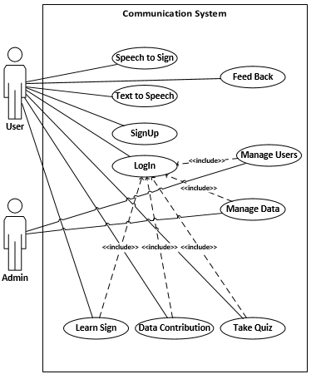

**4.3. Fully Dressed Use Cases and SSDs:**

**4.3.1(a) Fully Dressed Usecase for Sign Up of the User**

**Use Case UC1:** Sign Up of user

* **Scope:** Website
* **Primary Actor:** Normal Person, Imapired Person.
* **Stakeholders and Interests:**
* **Normal Person:** Person who is normal and want to communicate with the deaf and dumb person.
* **Imapired Person:** Person who is deaf and dumb and want to communicate with the normal person or want to learn signs of American Sign Language.
* **Preconditions:** Normal person or the imapired person is not registered and have no account.
* **Sucess Guarentee:** Normal person or the imapired person is registered and have an active account..
* **Main Success Scenario:**

1. Normal person or the imapired person enters username, password, re-password,
2. System match the password
3. User enter email.
4. System validates email.
5. User is registered.

* **Extensions:**

**\*a.** **Registration cannot be complete.**

**1. Invalid Username or Password:**

**1a.** Enter correct username and password.

**2. Password not match.**

**2a.** Enter correct password both of time i.e. password and re-password.

**3. Incorrect E-mail:**

**3a.** Enter correct email.

* **Special Requirements:**
  + User interface of system.
  + Language and wording must cleared.
* **Frequency of Occurrence:**
* Could be single time.
* **Open Issues:**
* Is E-mail already in use?
* Is the device is connected to internet.

**4.3.1(b) System Sequence Diagram For SignUp :**



**4.3.2 (a) Fully Dressed Usecase For Login of User**

**Use Case UC2:** Log in

* **Scope:** Website
* **Primary Actor:** Normal Person, Imapired Person, Admin.
* **Stakeholders and Interests:**
  + **Normal Person:** Person who is normal and want to communicate with the deaf and dumb person.
  + **Imapired Person:** Person who is deaf and dumb and want to communicate with the normal person or want to learn signs of American Sign Language.
  + **Admin:** Person who is managing the system.
* **Preconditions:**
* Person should have registered before.
* Person should be connected to internet.
* **Sucess Guarentee:** User will be logged in.
* **Main Success Scenario:**

1. Person enters the email and password.
2. The System verifies all of the given information and successfully and log in the person

* **Extensions:**

**a* At any time server is down.**

1. All the given information is lost.

1a. Person waits for server up and perform all the processes again.

**b* At any time application is closed.**

1. Person open the application and repeat all the steps again.

**1a. Person enter invalid information.**

1. Person is request to enter valid username or password.

**2b. Any required field is missing.**

1. Person enter valid information to required field.

* **Special Requirements:**
  + Language should be understandable.
  + Interface should be interactive for example mobile or web interface.
* **Frequency of Occurrence:**
* Could be continuous.
* **Open Issues:**
* Should any option given to person to contact Admin?
* Should any option given to user to report for poor interacting interface or sign availability issues?

**4.3.2 (b) System Sequence Diagram For Login:**

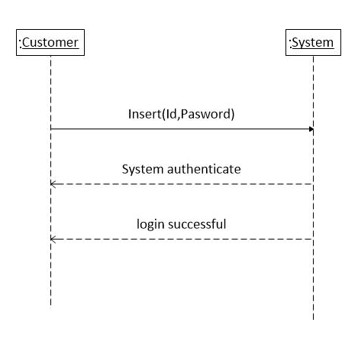

**4.3.3 (a) Fully Dressed Usecase for Speech to Sign**

**Use Case UC3:** Speech to Sign

* **Scope:** Website
* **Primary Actor:** User
* **Stakeholders and Interests:**
  + **User:** Person who is using the website. It can be register or unregister user.
* **Preconditions:**
* Person should have open Speech to Sign webpage.
* **Sucess Guarentee:** Person should have got his/her desired Sign.
* **Main Success Scenario:**

1. Person speaks to generate some text.
2. System validates the given text with its database.
3. Sign against the text will be shown onto the screen.

* **Extensions:**

**a* Internet not available.**

1. Sign not shown to the user.

1a. Person waits for internet connection and perform all the processes again.

**b* At any time server is down.**

1. Person waits for server up and repeat all the steps again.

**2b. Speech not found at database.**

1. Person will be ask to speak again until the given text do not match with the any sign.

* **Special Requirements:**
  + Internet.
  + Language should be understandable.
  + Interface for users.
* **Frequency of Occurrence:**
* Could be continuous.
* **Open Issues:**
* Should any translator provided to the user to use?
* Should any option given to person to report for poor interacting interface?

**4.3.3 (b) System Sequence Diagram For Speech to Sign:**



**4.3.4 (a) Fully Dressed Usecase for Text to Speech**

**Use Case UC4:** Text to Speech

* **Scope:** Website
* **Primary Actor:** User
* **Stakeholders and Interests:**
  + **User:** Person who is using the website. It can unresgister or register user.
* **Preconditions:**
* Person should have open Text to Speech webpage.
* **Sucess Guarentee:** Person should have gotten the required speech.
* **Main Success Scenario:**

1. Person enters the text into text-area.
2. System validates the given text with its database.
3. System speech out the given text.

* **Extensions:**

**a* At any time server gets down.**

1. All the given text is lost.

1a. Person waits for server up and perform all the processes again.

**b* At any time website is closed**

1. Person open the website and repeat all the steps again.

**2b. Language not found.**

1. User used unknown language.
   1. User must use standard language like English.

* **Special Requirements:**
  + Internet.
  + Interface for users.
* **Frequency of Occurrence:**
* Could be continuous.
* **Open Issues:**
* Should any language options given to the user to choose?
* Should any translator provided to the user to use?

**4.3.4 (b) System Sequence Diagram For LogIn:**



**4.3.5 (a)Fully Dressed Use case for Manage User**

**Use Case UC5:** Manage User

* **Scope:** Web Site
* **Primary Actor:** Admin
* **Stakeholders and Interests:**
* **Admin**: Admin can view the details of images or signs uploaded by the user.
* **Preconditions:** Admin have the account in the database of the website.
* **Success Guarentee:** Admin successfully manages the information of users visiting the website or learning the system.
* **Main Success Scenario:**
* **Basic Flow** – Retrieve basic information of user

|  |  |
| --- | --- |
| Actors Action | System response |
| 1.For information select user profile |  |
|  | 2.System display the selected records |
| 3. Apply CRUD operation on them |  |
|  | 4.System will do specified operation |

* **Extensions:**
* **Update the elements of User(Normal or Impaired person)**

1)  Selects to edit user information.

2) Use case flow continues with basic flow from steps 2-4.

3) Admin edits the information and confirms it.

4) System checks data for consistency.

5) System saves information and gives confirmation message.

* **Alternate Sub-Flow:**

**5(a)   Inconsistent data:**

1. System signals error and rejects to save the edited information

**5(b) Essential field left empty:**

  1. System signals error and rejects to save the edited information

2. Admin account issue, enters the missing data and retries to save the edited information.

* **Deletion information from profile:**

1)  Select to delete User’s information.

2)  Use case flow continues with basic flow from steps 2-4.

3)  Selects to delete the data.

4) System ask to confirm deletion.

5)  Confirm deletion.

6) System deletes the data and displays confirmation message.

* **Alternate Sub-Flow**:

**5(a)   Inconsistent data:**

3. System signals error and rejects to save the edited information

**5(b) Essential field left empty:**

3. System signals error and rejects to save the edited information

4.  Admin account issue, enters the missing data and retries to save the edited information.

* **Special Requirements:**
  + Internet for the Admin and application.
  + Access to data base
* **Frequency of Occurrence:**
* Could be continuous.
* **Open Issues:**
  + How to validate the data getting from Normal or the impaired person?

**4.3.5 (b) System Sequence Diagram For LogIn:**



**4.3.6 (a) Fully Dressed Usecase for Learn the Sign**

**Use Case UC6:** Learn the Sign

* **Scope:** Website
* **Primary Actor:** Registered user.
* **Stakeholders and Interests:**
  + **Normal Person:** Person who is normal and want to communicate with the deaf and dumb person.
  + **Imapired Person:** Person who is deaf and dumb and want to communicate with the normal person or want to learn signs of American Sign Language.
  + **Admin:** Person who is managing the system and have an active acoount to manage all the users.
* **Preconditions:**
* User must be regsiter and have login to open the Learn the sign webpage.
* **Sucess Guarentee:** Person should have got his/her desired Sign.
* **Main Success Scenario:**
  1. Person enters the name of the sign into input field.
  2. System validates the given name of sign with its database.
  3. System show relevant sign on to the screen.
* **Extensions:**

**a* At any time server is down.**

1. All the given information is lost.

1a. Person waits for server up and perform all the processes again.

**b* At any time website is closed.**

1. Person open the website and repeat all the steps again.

**2b. Language not found at database.**

1. User used unknown language.
   1. User must use standard language like English.

* **Special Requirements:**
  + Internet.
  + Language should be understandable.
  + Interacting interface for example mobile or web.
* **Frequency of Occurrence:**
* Could be continuous.
* **Open Issues:**
* Should any language options given to the user to choose?
* Should any hint for a sign provided to the user to use?

**4.3.6 (b) System Sequence Diagram For Search for Sign:**



**4.3.7 (a) Fully Dressed Usecase for Contribute to Data**

**Use Case UC7:** Contribute to Data

* **Scope:** Website
* **Primary Actor:** Regisered user
* **Stakeholders and Interests:**
  + **Registered user:** User who have registered before and have an access to the quiz page by login him/herself.
* **Preconditions:**
* User must be regsiter and have login to open the Learn the sign webpage.
* **Sucess Guarentee:** Person should have uploaded the sign successfully.
* **Main Success Scenario:**

1 Person choose the file which he/she want to upload from the device and enter the name or relevant information to the description field.

2 User enter email to get validated.

3 System validates the email from the database

* 1. System shows the message of “successfully uploaded the sign”.
* **Extensions:**

**a* Size of sign is large.**

1 System show error message.

1a. Person select the limited sign or change the sign.

**b* At any time website is closed.**

1 Person open the website and repeat all the steps again.

**2b. User enters the incorrect email.**

* + 1. Email don’t belong to any user.

2a. User check the given email and correct it.

* **Special Requirements:**
  + Internet.
  + Language should be understandable.
  + Interface should be interacting.
* **Frequency of Occurrence:**
* Could be continuous.
* **Open Issues:**
* Should any sign size limit given to the user?
* Should user upload the sign without email?

**4.3.7 (b) System Sequence Diagram For Contribution to DB:**



**4.3.8 (a) Fully Dressed Usecase for Take Quiz**

**Use Case UC8:** Take Quiz

* **Scope:** Website
* **Primary Actor:** Regisered user
* **Stakeholders and Interests:**
  + **Registered user:** User who have registered before and have an access to the quiz page by login him/herself.
* **Preconditions:**
* User must be regsiter and have login to give the quiz.
* **Sucess Guarentee:** Person should have uploaded the sign successfully.
* **Main Success Scenario:**

1 Person visit the quiz page

2 Person choose the given options with in time

3 Person sumit all the given answers with in the time.

4 System validates the answer choosen by the person.

5 System shows the result againts the given answers

* **Extensions:**

**a* Time ran out.**

1. Person stops and refresh the page.

1a. Person again answer the given questions.

**b* At any time quiz page is closed.**

1. Person open the quiz page and repeat all the steps again.

* **Special Requirements:**
  + Internet.
  + Language should be understandable.
  + Interacting interface for example mobile or web.
* **Frequency of Occurrence:**
* Could be continuous.
* **Open Issues:**
* Should any way to quit the quiz?
* Should the person increase the time?
* Should the person submit without answering any question?

**4.3.8 (b) System Sequence Diagram For Take Quiz:**



**4.3.9 (a) Fully Dressed Usecase for Feedback**

**Use Case UC9:** Feedback

* **Scope:** Website
* **Primary Actor:** Normal person, Impaired person.
* **Stakeholders and Interests:**
  + **Normal Person:** Person who is normal and want to communicate with the deaf and dumb person.
  + **Imapired Person:** Person who is deaf and dumb and want to communicate with the normal person or want to learn signs of American Sign Language.
  + **Admin**: Admin can view the feedback given by the user.
* **Preconditions:**
* User must be on the website and have a facebook account loged in
* **Sucess Guarentee:** Person should have given the feedback successfully.
* **Main Success Scenario:**

1 Person visit the main page of the website and scroll down to the feedback portal.

2 By using the facebook account user can give the feedback about the website.

3 The feedback will be shown to the facebook as well as on the main page with the username.

* **Extensions:**

**\*a.** **Add the account.**

**1. Invalid Username or Password:**

**1a.** Enter correct username and password.

**2. Password not match.**

**2a.** Enter correct password both of time i.e. password and re-password.

**3. Incorrect E-mail:**

**3a.** Enter correct email.

**\*b.** **Internet not available**

1. All the given information lost.

1a. User renter all the information again.

* **Special Requirements:**
  + Facebook.
  + Language should be understandable.
* **Frequency of Occurrence:**
* Could be continuous.
* **Open Issues:**
* Should any other way to give the feedback than Facebook?
* Should the user can give feedback without any account?
* Should any way to give feedback without visiting website?

**4.3.9 (b) System Sequence Diagram For Feedback:**



**Chapter 5**

**System Design**

**5.** **System Design:**

User can communicate with deaf and dumb people via speech to sign and they can communicate with us with text to speech option and if user want to serve to our vocabulary he can also add signs. And by quiz option he can also evaluate that how much he knows about ASL signs.

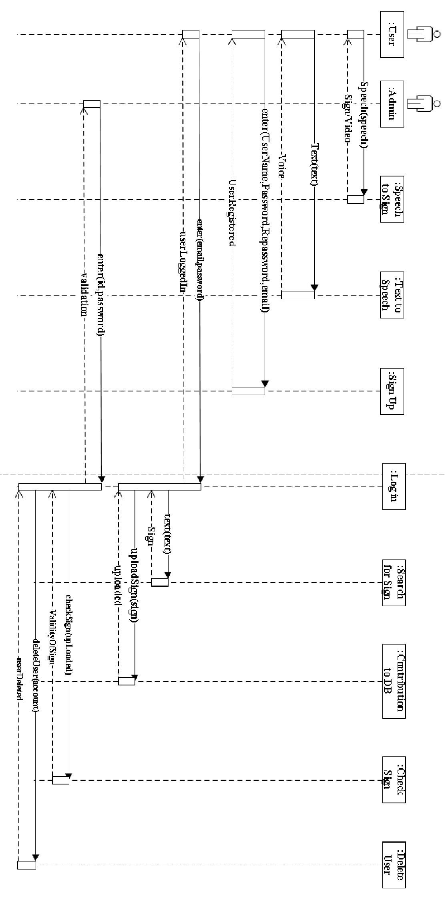**5.1 Sequence Diagram:  
5.2 Class Diagram:**

Fig5.1

 Fig5.

**Chapter 6**

**Implementation**

**6. Implementation:**

Implementation introduces how this project is implemented on system. The development tool is used to implement the design and mention, reason for selecting the tools are also discussed. Then the modules being translated into the implementation tools are also discussed. Then the modules being translated into the implementation tools are described.

**6.1. Tools**

The following tools and technologies are used to build the application:

1. Visual Studio
2. SQL Server
3. Adobe Photoshop

**6.1.1 Visual Studio:**

Visual studio is an integrated development environment made by Microsoft for developer to create application for windows desktop PC and for mobiles i.e. IOS, Android, and for Windows also. It has number of comprehensive facilities for example it has its own editor for source code as well debugger with multiple computer languages support on a single platform.

**6.1.2 SQL Server:**

SQL server is DBMS data base management system made by Microsoft. This product use to handle relational data basses for instance its basic functionalities include storing and retrieving of data. By using this tool data can be access store retrieve the data on the same computer and can be access from other computers for example from other network or from the Internet.

**6.1.3 Adobe Photoshop:**

Adobe Photoshop is the predominant photo editing and manipulation software on the market. Its uses range from full featured editing of large batches of photos to creating intricate digital paintings and drawings that mimic those done by hand. The software provides many image editing features for raster (pixel-based) images as well as vector graphics. It uses a layer-based editing system that enables image creation and altering with multiple overlays that support transparency. Layers can also act as masks or filters, altering underlying colors. Shadows and other effects can be added to the layers. Photoshop actions include automation features to reduce the need for repetitive tasks. An option known as Photoshop CC (Creative Cloud) allows users to work on content from any computer.

**6.2 Designing of Interface:**

User interface designing in other words users interface engineering is the broad field design of different websites, desktop applications (apps), Mobile Application and Software Application just to provide users a better user experience and made his interaction to our website app mobile app or desktop app easy efficient and productive. In terms for increasing the user experience goals what is often called User Centered Design. Graphics are used to increase the final products usability. The process for designing must be in balanced between the technical functionalities to create the system operational as well as adaptable to changing user needs.

The designing of interface has number computer sciences projects for example CAD (Computer Aided Design) for designing of cars, commercial Planes designing. Whether that be software designing, user research, web design, or industrial design. Their basic goal is to provide a user an easy way to interact and communicate with our system.

**6.3 User Friendly Design:**

While designing it is most complex and nervous for designer because a good and high usability base system must have an interface which is easy to use i.e. User Friendly, for that designer should have a well define plan so which can be executed so one can organize and design his system according to users per requirements.

**6.4 Some Basic Features of UI**

**6.4.1 Navigation:**

It is easy for user to navigate through out your web site easily, our website also provide all the major option on eyeball view so user can easily interact with his meaningful option which are provided to him

**6.4.2 Informative:**

Your system should be more informative enough so a user who is interacting very first time with your system can get the information about functionality of your system. in our system we also mention notes, validations, labels to guide our user to the right track. Which make user more comfortable because all the option are available in simple way at the distance of your mouse click.

**6.5 Database Implementation:**

For an efficient system or web site it is necessary that it has database base behind it which help it to do its operations more smoothly related to data. And made data more secure and consistent. We also use database in our website so large number of data ca be mange easily without any complexion, we have different Data table for different tasks for example to manage users registration information, users Quiz information, data basses related to signs admin sign Check etc.

**6.5.1 Registration Table:**

This table contain the registration information of all the registered user who want to access learning and evaluation facilities and also who want to contribute to our data base e.g. by uploading any photo and video

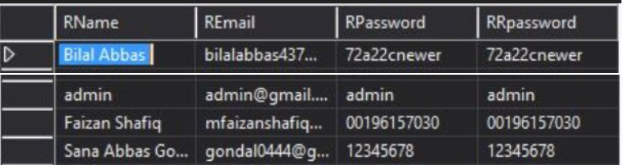

Fig 6.1

**6.5.2 For User Logs:**

Registered users login information are noted in this table and also they are authenticated here. When they login then can access authorize facilities.

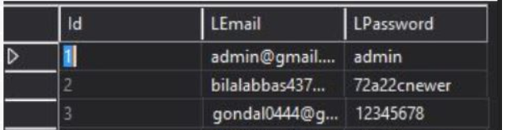

Fig 6.2

**6.5.3 Quiz Table:**

Quiz which is given to the learner user is given multiple choice question from this table.

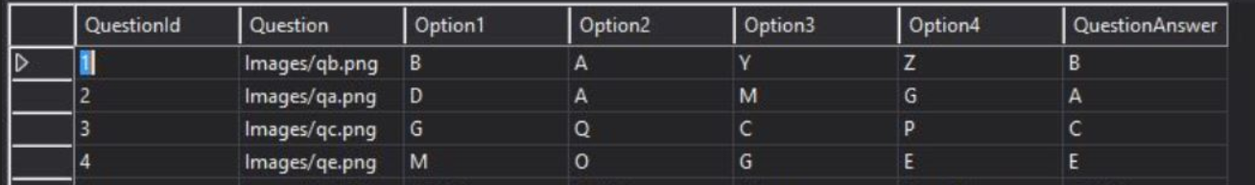

Fig6.3

**6.5.4 Contributor’s Table:**

If any user who know any sign that is not in our data base can upload and do contribution for our data base which is very valuable for other users, but if any user do any malicious activity i.e. upload abusive photos so to handle these type of users admin can delete their account so they can’t upload any data again.

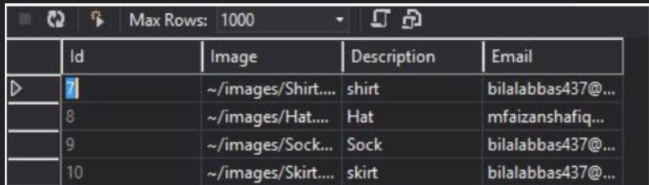

Fig 6.4

## 

## 

## **Chapter 7**

**Testing**

**7. Testing:**

Web site testing is basically a testing of web application for example looking for bugs, check if web site crash due to some reason, it also includes functionality of website, connectivity of data base, browsers compatibility, responsiveness.

* 1. **Functionality Testing:**This testing includes as per functional requirements are meeting or not for example basic modules are working correctly or not.
     1. **Testing Of Speech to Sign.**

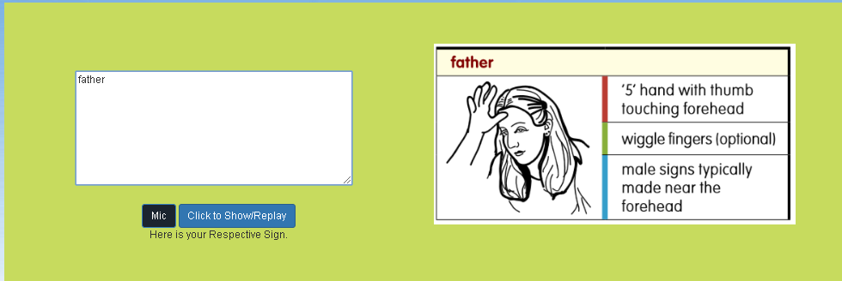

Fig (7.1)

|  |
| --- |
| **Test Case #:** Test Case 1 **Test Case Name:** Home Page Navigation Test  **System:** ASL base communication and learning system **Subsystem:** Speech to Sign |

|  |
| --- |
| **Pre-conditions:** Browser should Mic enabled |

|  |  |  |  |
| --- | --- | --- | --- |
| Step | Action | Expected System Response | **Fail/ Pass** |
| 1 | Click and hold “Mic” button. | Systems mic is activated and de-activated on release of button. | Pass |
| 2 | Click “Click to Show/Replay” button. | Show the ASL sign against the spoken words. | Pass |
| 3 | Click and hold “Mic” button and don’t speak | A message appear under the buttons “Please Speak something” | Fail |
| 4 | Click and hold “Mic” button speak un known word | A message appear data not found. | fail |

|  |
| --- |
| **Post-conditions** User will be able to see the sign |

* + 1. **Testing Of Text to Speech.**

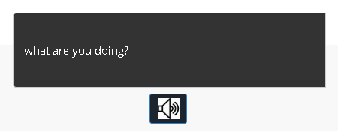

Fig (7.2)

|  |
| --- |
| **Test Case #:** Test Case 2 **Test Case Name:** Text to speech  **System:** ASL base communication and learning system **Subsystem:** Speech to Sign |

|  |
| --- |
| **Pre-conditions:** Browser should have access to audio output devices |

|  |  |  |  |
| --- | --- | --- | --- |
| Step | Action | Expected System Response | **Fail/ Pass** |
| 1 | Write text in text area | Text is shown in text are box | Pass |
| 2 | Click “Speaker” button. | The written text converted into speech. | Pass |

|  |
| --- |
| **Post-conditions** User will be able to convert his words to speech. |

* + 1. **Testing Of Learning and Evaluation:**

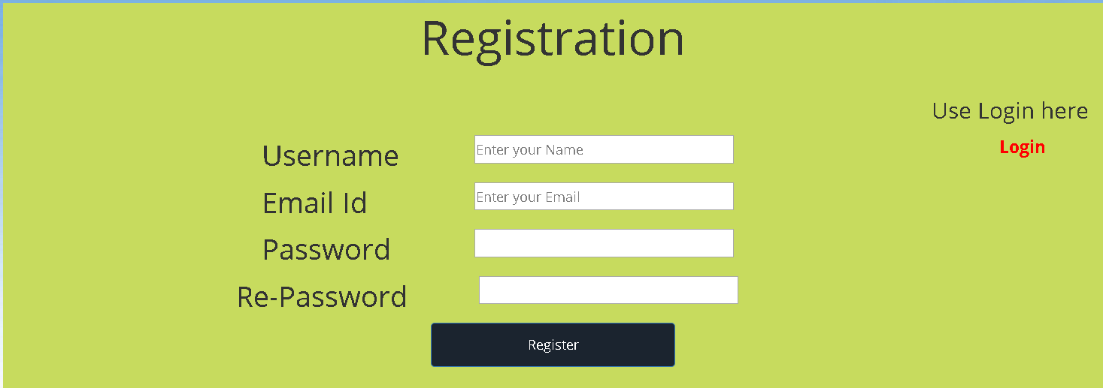

Fig (7.3)

|  |
| --- |
| **Test Case #:** Test Case 1 **Test Case Name:** Registration  **System:** ASL base communication and learning system **Subsystem:** Registration of user |

|  |
| --- |
| **Pre-conditions:** User is not registered with same E-mail ID. |

|  |  |  |  |  |
| --- | --- | --- | --- | --- |
| **Step** | **Action** | **Expected System Response** | **Pass/ Fail** | **Comment** |
| 1 | Enter the User name. |  | Pass |  |
| 2 | Field is empty. |  | Fail |  |
| 3 | Enter email ID |  | Pass |  |
| 4 | Enter the Password. |  | Pass |  |
| 5 | Reenter the Password. |  | Pass | Reenter the same password as above |
| 6 | Click the Sign up button. | The website should display an error message of “Please fill out the field. | Fail |  |
| 7 | Click on login link | Shift to login page | Pass |  |

|  |
| --- |
| **Post-conditions:** User will not be able to Sign up. |

* + 1. **Test of Login:**

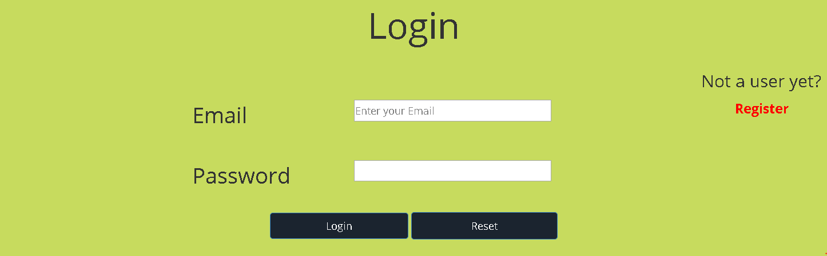

Fig (7.4)

|  |
| --- |
| **Test Case #:** Test Case 2 **Test Case Name:** LogIn  **System:** ASL base communication and learning system **Subsystem:** User LogIn |
| **Pre-conditions:** User must have to register his self**.** |

|  |  |  |  |  |  |
| --- | --- | --- | --- | --- | --- |
| **Step** | | **Action** | **Expected System Response** | **Pass/ Fail** | **Comment** |
| 1 | | Enter the Email. |  | Pass |  |
| 2 | | Enter the password. |  | Pass |  |
| 3 | | Click on login button | User will log in | Pass | If id and password is wrong the system will generate error |
| **Post-conditions:** User will now able to access learning and evaluation options. | | | | |

* + 1. **Testing Of Learning and Evaluation:**

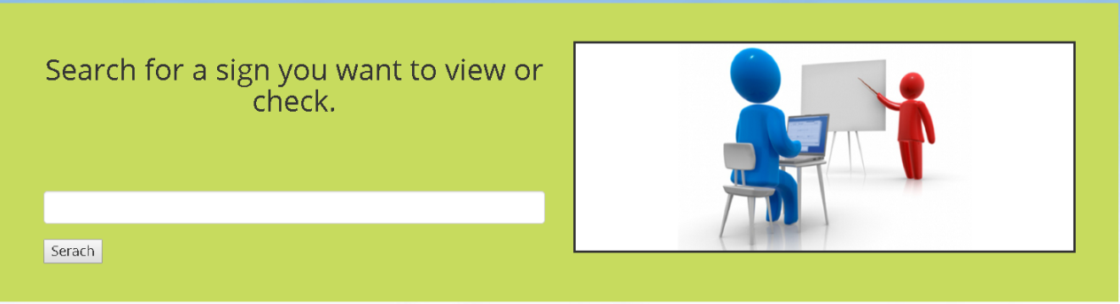

Fig (7.5)

|  |
| --- |
| **Test Case #:** Test Case 3 **Test Case Name:** Search for Sign  **System:** ASL base communication and learning system **Subsystem:** learning and search for sign |

|  |
| --- |
| **Pre-conditions:** user must have to login. |

|  |  |  |  |
| --- | --- | --- | --- |
| Step | Action | Expected System Response | **Fail/ Pass** |
| 1 | Write text in text box | Text is shown in text are box | Pass |
| 2 | Click “Sesrch” button. | The written text’s related sign shown on right side window | Pass |

|  |
| --- |
| **Post-conditions** User will be able to learn the sign. |

* + 1. **Testing Of Contribution section**

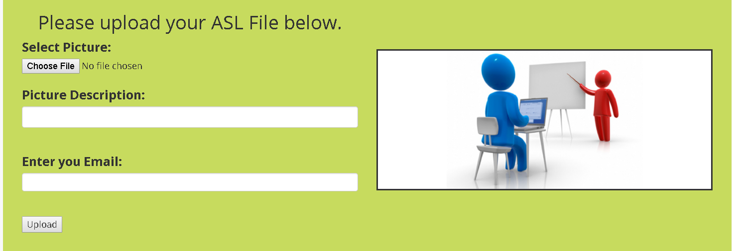

Fig (7.6)

|  |
| --- |
| **Test Case #:** Test Case 4 **Test Case Name:** Contribution  **System:** ASL base communication and learning system **Subsystem:** Contribution to DB |

|  |
| --- |
| **Pre-conditions:** user must have to login. |

|  |  |  |  |
| --- | --- | --- | --- |
| Step | Action | Expected System Response | **Fail/ Pass** |
| 1 | Click “Choose file” button. | Show file explorer to choose files | Pass |
| 2 | Enter text into description text box. | The written text’s related sign shown on right side window | Pass |
| 3 | Enter Email id. | Check valid email id or not | Pass |
| 4 | Enter in valid id | Show validation error | Fail |

|  |
| --- |
| **Post-conditions** User will be able to upload picture to our data base. |

* + 1. **Testing Of Manual Alphabets**

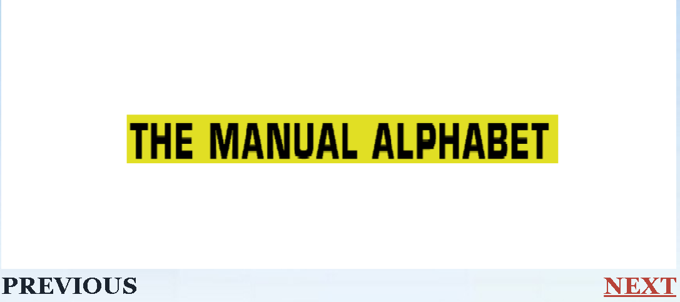

Fig (7.7)

|  |
| --- |
| **Test Case #:** Test Case 5 **Test Case Name:** Manual Alphabets for Sign  **System:** ASL base communication and learning system **Subsystem:** Manual Alphabets |

|  |
| --- |
| **Pre-conditions:** user must have to login. |

|  |  |  |  |
| --- | --- | --- | --- |
| Step | Action | Expected System Response | **Fail/ Pass** |
| 1 | Click “PREVIOUS” button. | Show the previous ASL Alphabet sign. | Pass |
| 2 | Click “NEXT” button. | Show the next ASL Alphabet sign. | Pass |

|  |
| --- |
| **Post-conditions** User will be able to learn the ASL alphabet signs. |

* + 1. **Testing of Quiz:**

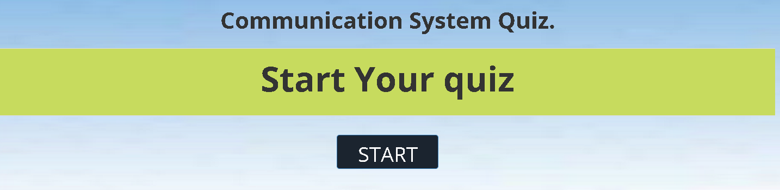

Fig (7.8)

|  |
| --- |
| **Test Case #:** Test Case 6 **Test Case Name:** Quiz  **System:** ASL base communication and learning system **Subsystem:** Quiz |

|  |
| --- |
| **Pre-conditions:** user must have to login. |

|  |  |  |  |
| --- | --- | --- | --- |
| Step | Action | Expected System Response | **Fail/ Pass** |
| 1 | Click “START” button. | Quiz window will appear with started timer. | Pass |

|  |
| --- |
| **Post-conditions** User can give the quiz. |

* + 1. **Testing of Quiz:**

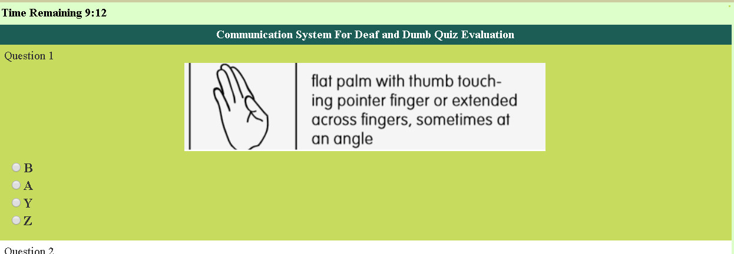

Fig (7.9)

|  |
| --- |
| **Test Case #:** Test Case 6 **Test Case Name:** Quiz  **System:** ASL base communication and learning system **Subsystem:** Quiz Window |

|  |
| --- |
| **Pre-conditions:** user must have to login. |

|  |  |  |  |
| --- | --- | --- | --- |
| Step | Action | Expected System Response | **Fail/ Pass** |
| 1 | Choose “Radio Button” from all of given questions | System will evaluate score according to choose option true or false. | Pass |

|  |
| --- |
| **Post-conditions** User can give the quiz. |

* + 1. **Testing of FB Feedback:**

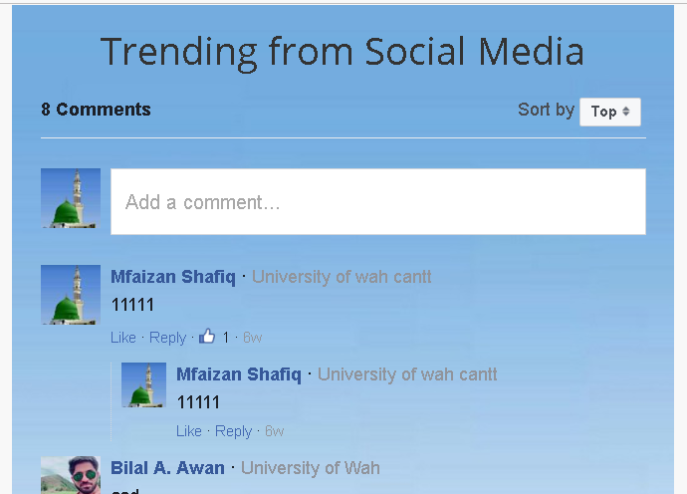Fig (7.9)

|  |
| --- |
| **Test Case #:** Test Case 7 **Test Case Name:** Feedback  **System:** ASL base communication and learning system **Subsystem:** Quiz Window |

|  |
| --- |
| **Pre-conditions:** user must have to login via Facebook account. |

|  |  |  |  |
| --- | --- | --- | --- |
| Step | Action | Expected System Response | **Fail/ Pass** |
| 1 | Enter text into comment box | Comment (feedback) will show on the home page via Facebook plugin. | Pass |
| 2 | User write abusive comment | Manage according to Facebook’s terms and conditions. | Pass |

|  |
| --- |
| **Post-conditions** User can give his valuable Feedback. |

* 1. **Compatibility Testing:**

In today’s web development environment the usability is prime focus of any web developer because web sites or web APPs has to operate on number of devices having different screen sizes ,differently operate, different way of navigation. So the web site to be perfect should have to be easy to use and also have cover todays market’s large number of devices including Mobile devices, laptops, desktop PCs etc.

* + 1. **Menu Testing**

Menu testing includes web page element how they react on any device. How responsive they are? They are visible easily or not. And consistent on all pages for example navigation bar has number of items i.e. links or button on it , what will happen to them if size of the browser windows decreased how may this size will effect size of images, slide show which is used input fields etc.



Fig (7.10)

This is the size of navigation bar on normal browser screen for maintain the usability of browser it should change its size according to size of the browser windows for instance.

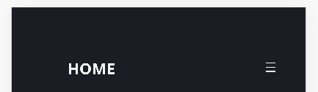 Before Tap After Tap

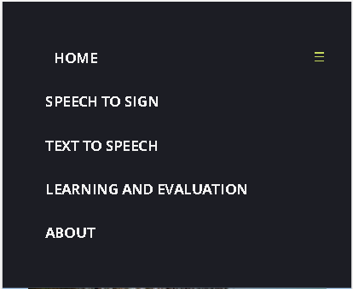

Fig (7.11a) Fig (7.11b)

This is the size of our website’s navigation bar on small device for example IPhone 5S (4 inch screen size).

 Before Tap After Tap



Fig (7.12a)

Fig (7.12b)

This is the size of our website’s navigation bar on small device for example IPhone 6, 7, 8, X plus and Samsung Galaxy 6,7,8,9 plus (5.5-5.8 inch screen size).

* + 1. **Web Page Testing:**

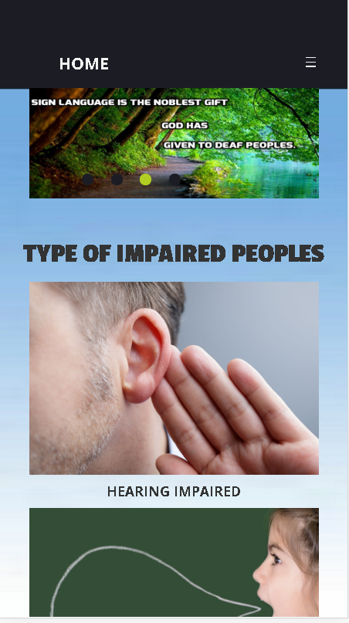Web page testing include that how a web page represents its contents on devices of different sizes for instance, following are some of the examples of Home pages of our website on devices e.g.

* Mini Display Devices
* Large Display Devices
* Extra-large Display Devices
* Desktop.

**7.3.2.1 Test on Mini Display Devises:**

The webpage automatically adjust its elements according to the size environment of the device.

Fig (7.13)

**7.3.2.1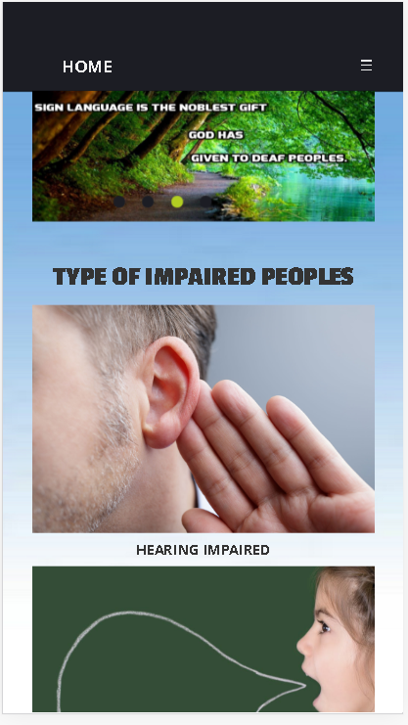 Test on large Display Devises:**

Large display devices include devices has screen size up to 5 inches to 5.8 inches. For example iPhone 6, 7, 8, X, Samsung S6, S7, S8, S9 etc.

Fig 7.14)

**7.3.2.3 Test on X-large Display Devises:**

Extra Large display devices include devices has screen size up to 9.7-inch to 10.5-inch. For example iPads of Apple and tablet 1, 2, 3 of Samsung.

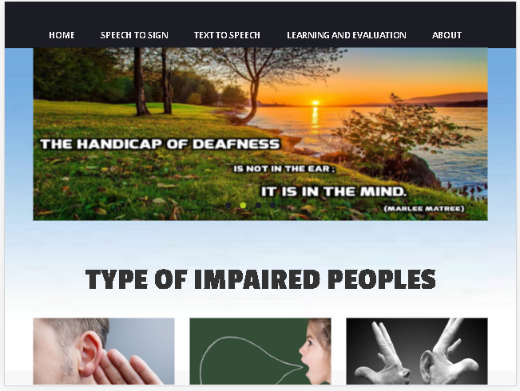

Fig (7.15)

**7.3.2.4 Test on Desktop Display Devises:**

Desktop display devices include devices has screen size up to 14-inch to 10.5-inch. For example iPads of Apple and tablet 1, 2, 3 of Samsung.

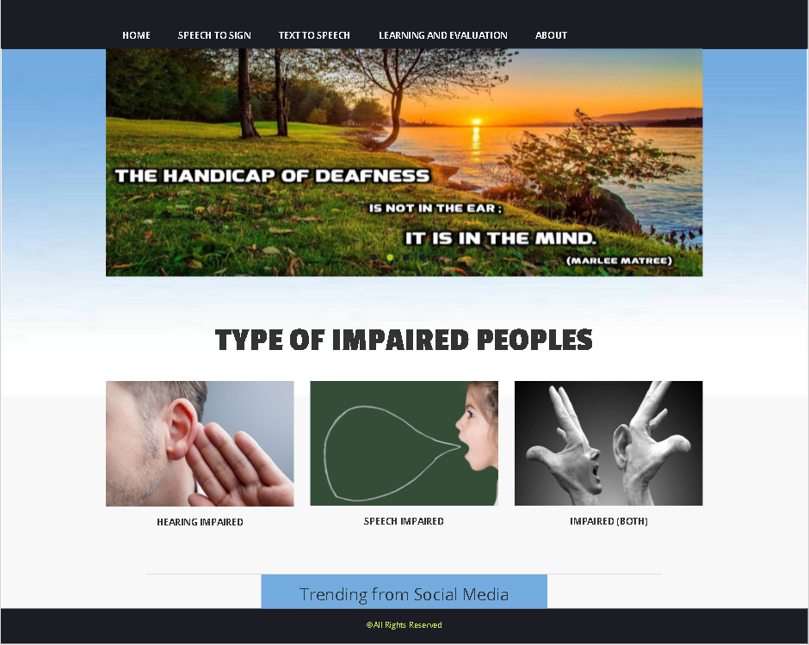

Fig (7.16)

* + 1. **Compatibility Testing on Different Browsers**

It is very important for a web site to compatible with number of browser. Because some browsers allow some type of scripting language but some browsers don’t, so some browser only accepts basic html (Hypertext markup Language) but most of browser along with basic html they are also allow CSS (Cascading Styling Sheet) and Ajax.

* + - 1. 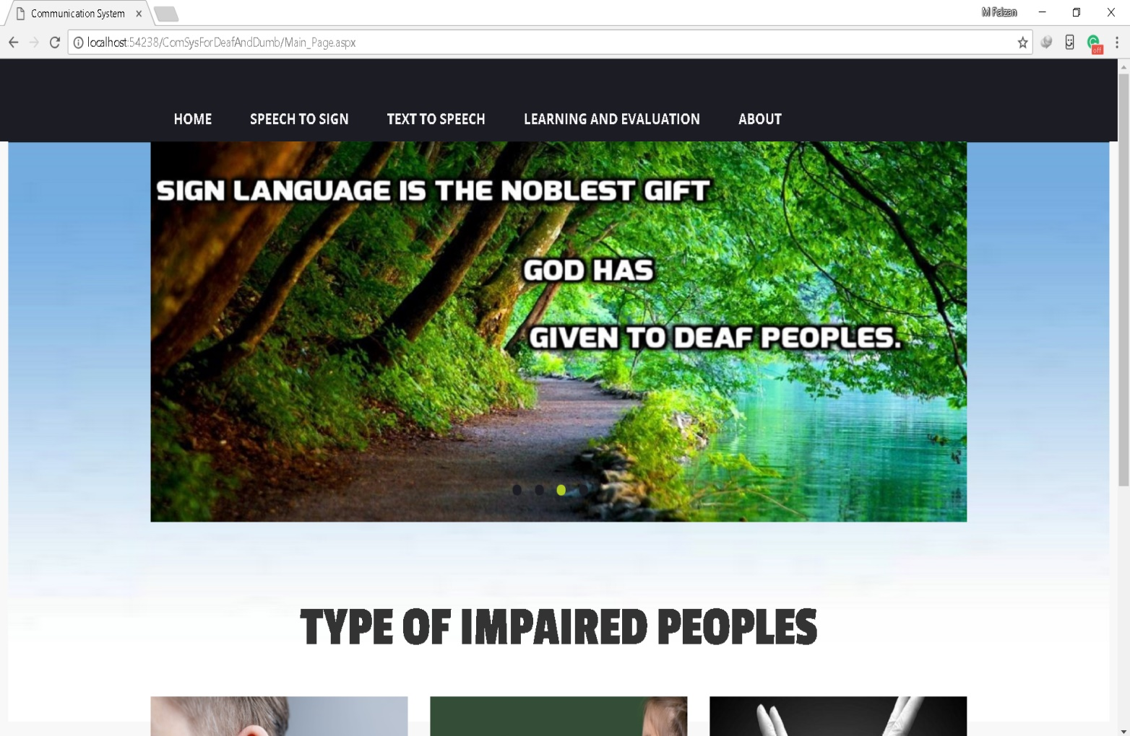**Testing on Google Chrome:**
      2. **Testing on Firefox:**

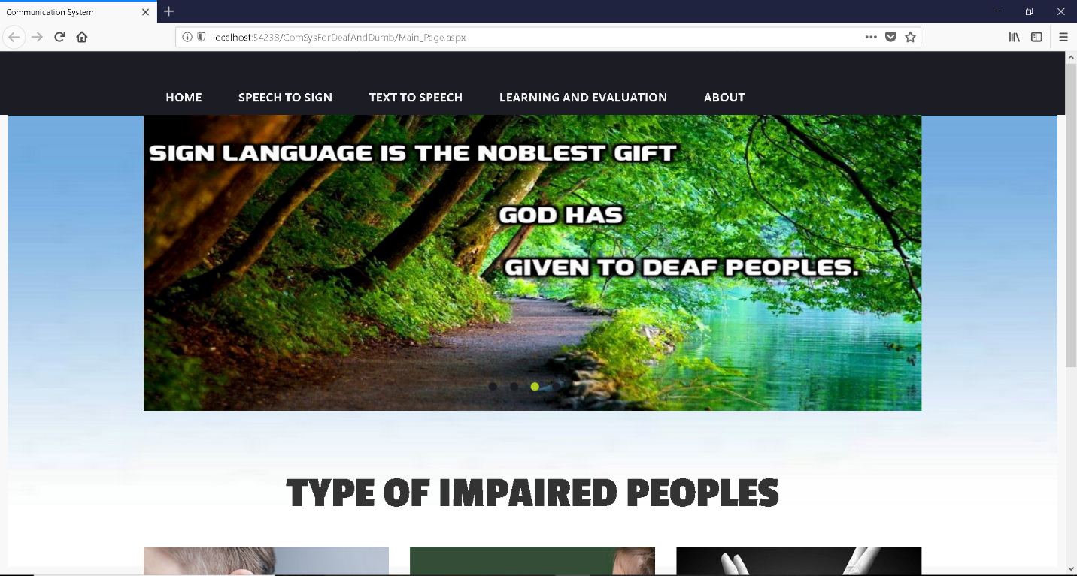

**Testing on Microsoft Edge:**

## **Chapter 8**

**User Manual**

**8.1 Users of System:**

1. Normal peoples

2. Hearing and speaking impaired.

**8.2 Main page of website:**

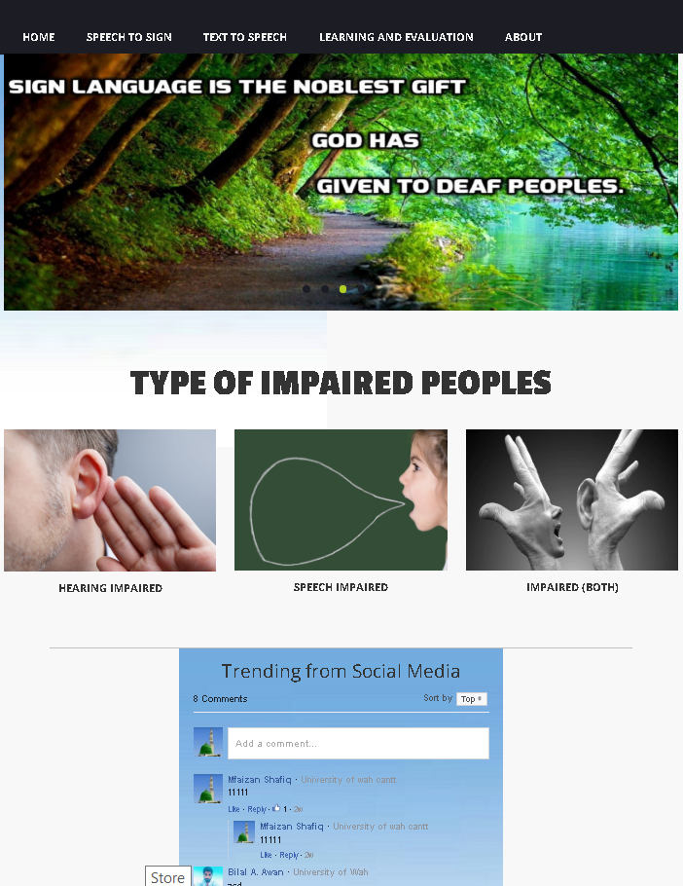

Section No.4 This image box has the detail of that type of peoples who can’t listen as well as speak

Section No.3 This image box has the detail of that type of peoples who can’t Speak.

Section No.2 This image box has the detail of that type of peoples who can’t listen

Section No.1 having links of different pages

Section No. 5

Social Media section

**Sec.1.1 Home:**

After the section 1 having all websites links we have following 3 sections which are**.**

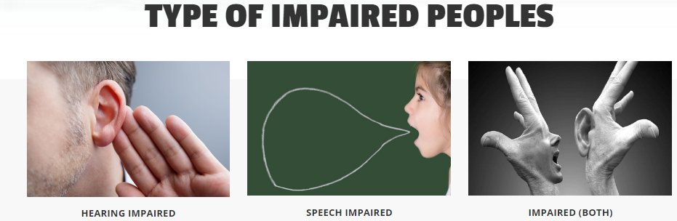

Section 4

Section 3

Section 2

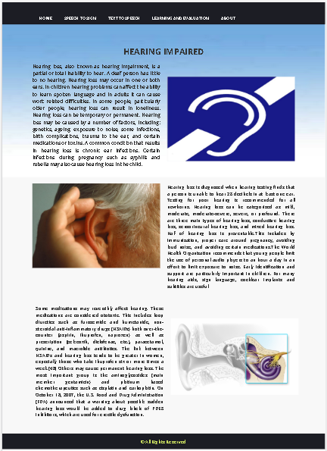**Section 2 (HEARING IMPAIRED)**

After clicking of user on this page a web page will appear having information about the peoples having week sensation of listening or impaired to listening completely.

Section 2.1 is the web page which will appear which is given.

**Section 3 (SPEECH IMPAIRED).**

After clicking of user on this page a web page will appear having information about the peoples having week sensation of speaking or impaired to speak completely

Section 2.2 is the web page which will appear is given.

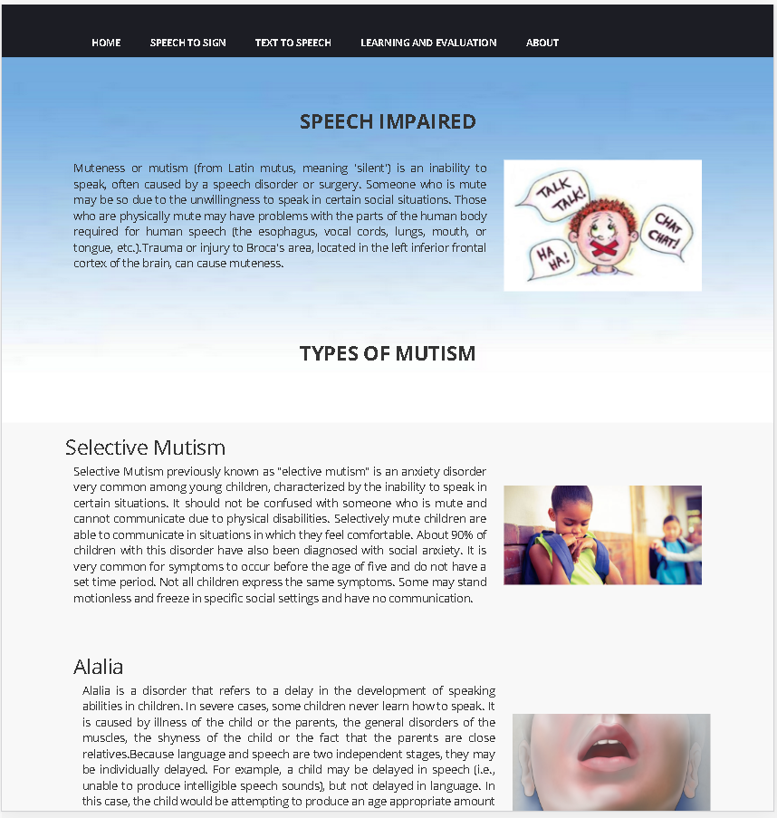**Section 4 (IMPAIRED BOTH).**

After clicking of user on this page a web page will appear having information about the peoples having week sensation of speaking and listening.

Section 2.2 is the web page which will appear is given.

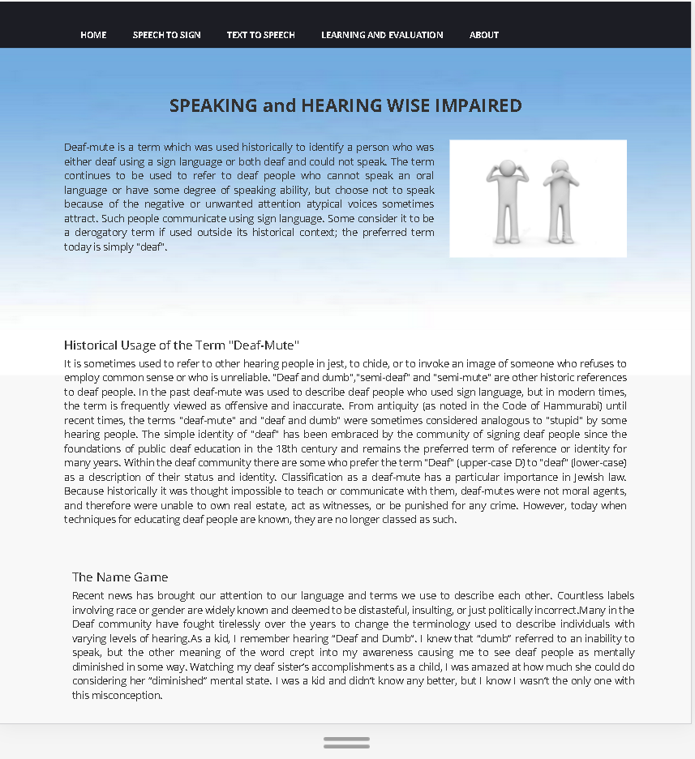

**Section 1.2(Speech to Text):**

After clicking this link tab the following web page will appear.

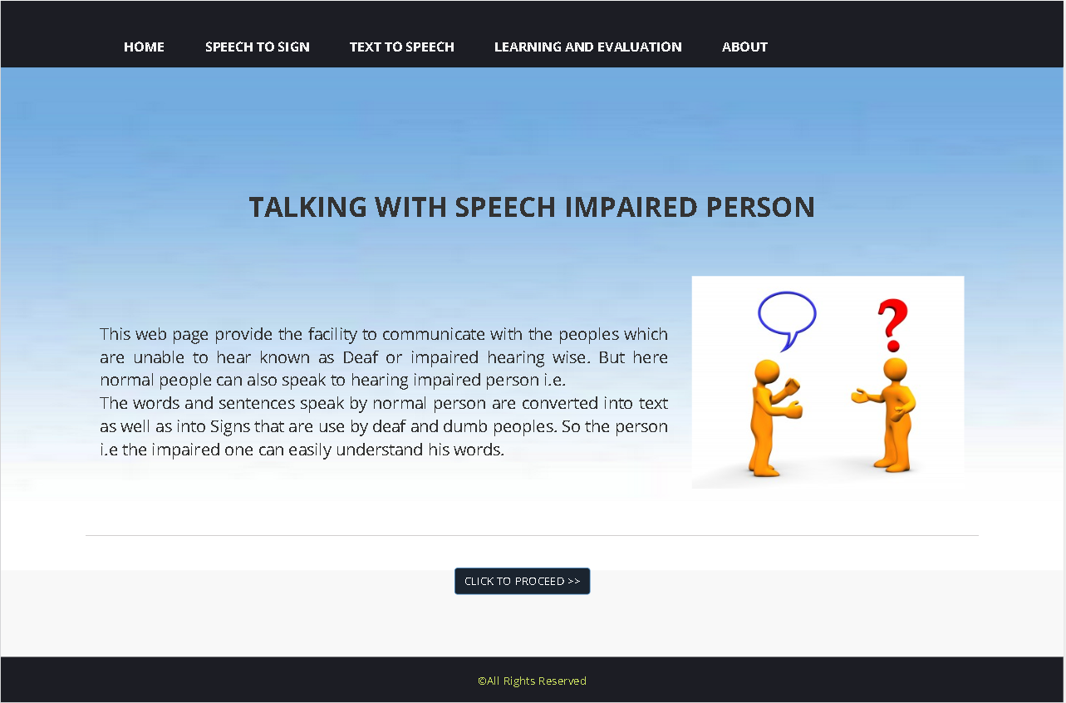

This button will provide Speech to sign web app.

**Section 1.2.1(WEB APP FOR COMMUNICATION):**

This page contain the following web app which will be used by normal user to communicate with peoples which are impaired hearing wise.

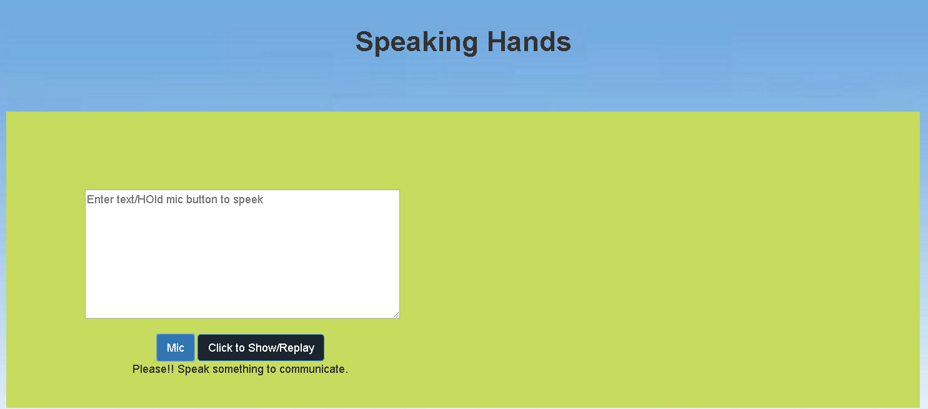

By clicking this button the speech recognition will stop.

By clicking this the app will start listening to the user (normal person)

This window shows extracted text from the user’s voice.

This window will show relevant sign so hearing impaired person can understand that what the normal person want to say.

**Section 1.3 (TEXT TO SPEECH):**

This page contain the web page having a web app for the speaking wise impaired persons who are unable to speak.so they type their respective words and app will speak out as it is.

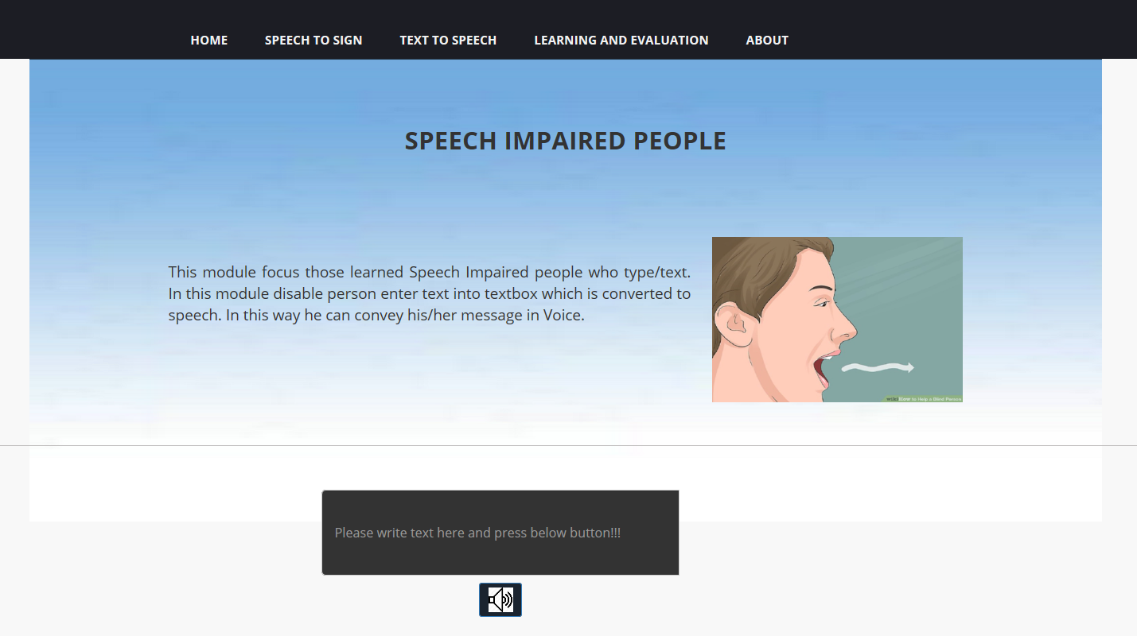

After entering text he/she have to click the button and app will convert the text into voice.

User (speaking) wise impaired person will type here.

**Section 1.4 (LEARNING AND EVALUATION):**

Before learning and evaluation link tab one have to go through the REGISTRATION and LOG-IN procedures so after clicking this tab following web page will appear.

**Section 1.4.1 (Registration):**

After clicking register link user following page will appear.

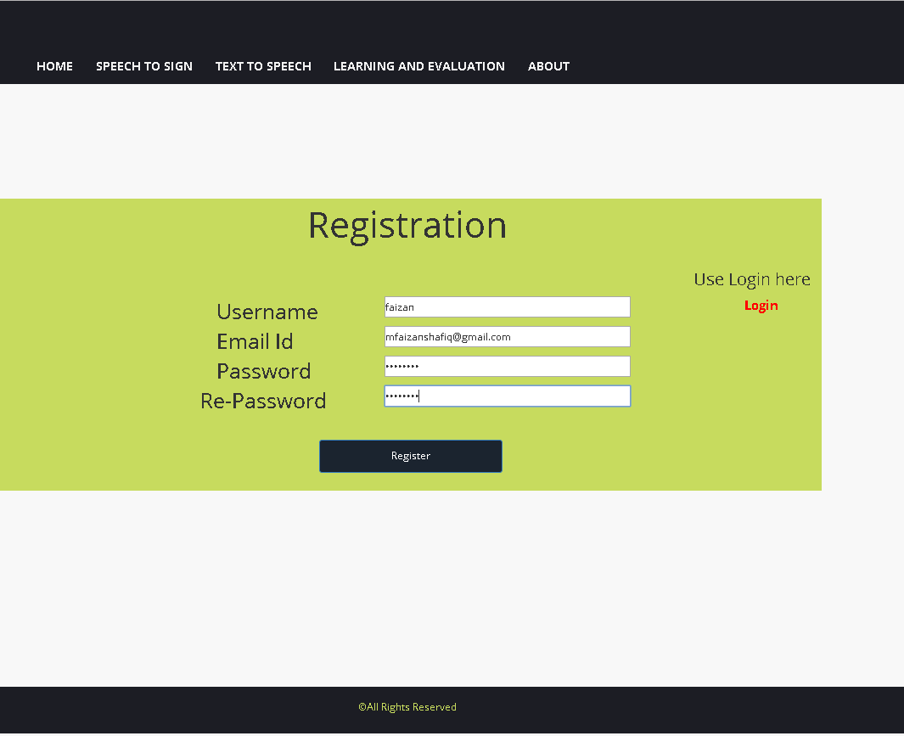

After filling the valid information click to register.

Enter valid email ID

For confirmation retype password

Enter user name which will be used for log in

Enter your respective password which will be use in future for login.

After click on Register button following confirmation popup will generate to conform registration.

After click on Register button following confirmation popup will generate to conform registration.

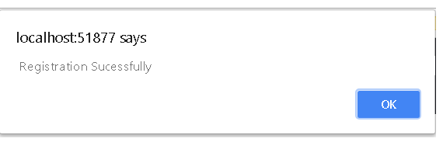

After this click on ok and then on login link.

**Section 1.4.2 (LOG-IN):**

Registered user will login here to access allowed options.

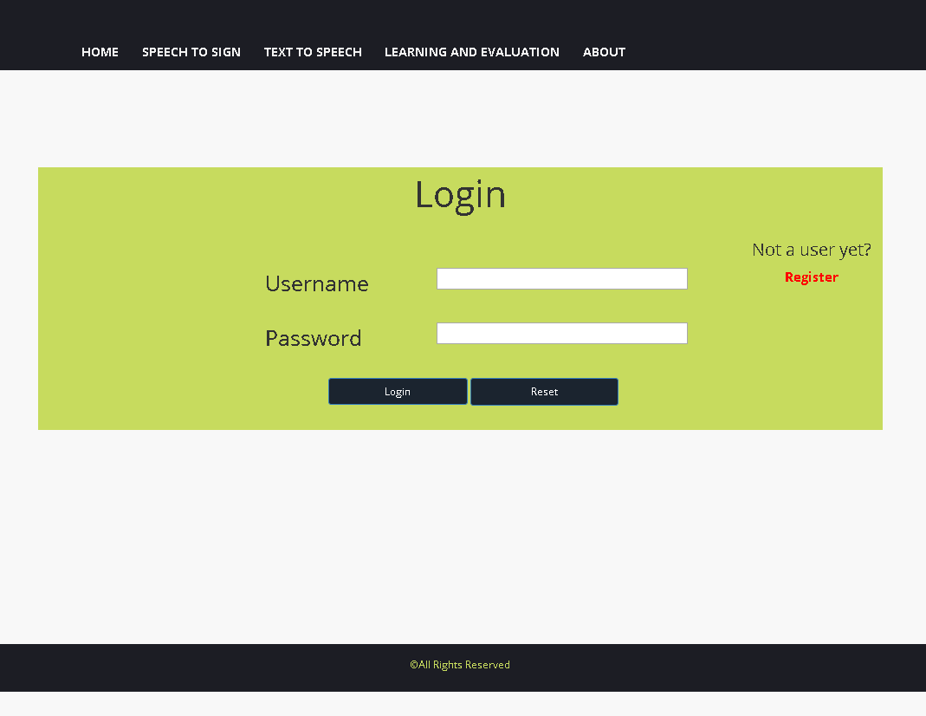

Click on this link for registration if you are not a registered user

Click this button to login after filling the above text fields.

Enter registered user name in this field

Enter your password

Click this button to reset the above text fields

**Section 1.4.2(after log in):**

**Following web page will appear.**

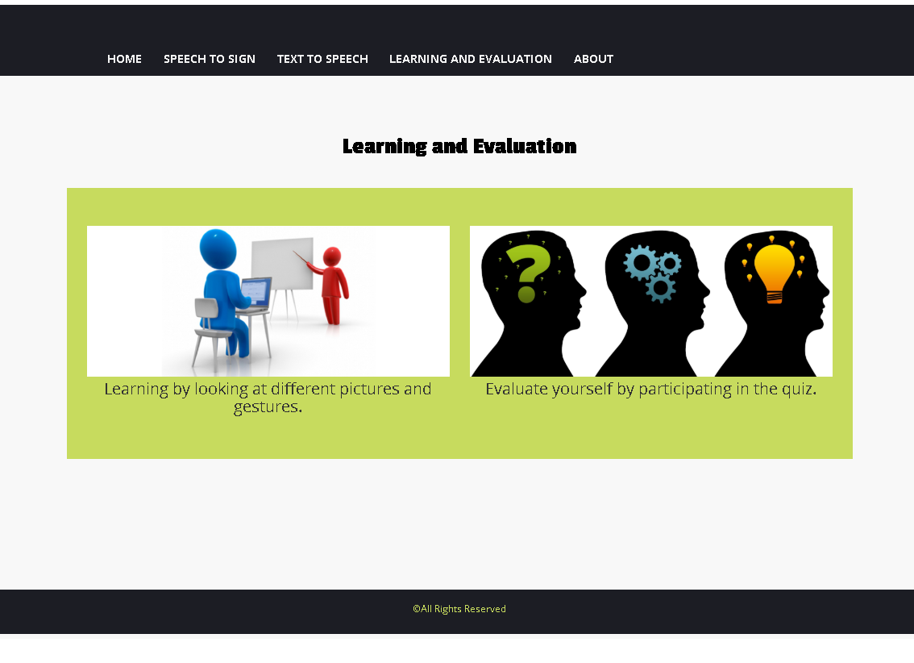

Section 1.4.2.2

For participating in Quiz

Section 1.4.2.1

For learning sign language

**Section 1.4.2(i) (Learning):**

This section is for the users who want to learn something e.g. by typing English words and learn the relevant meaning of that specific word.

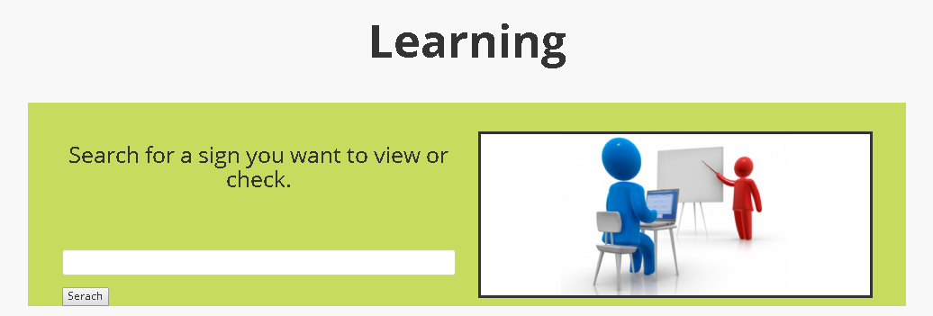

This field is use to enter text i.e. English words which you want to know

This window show the entered sign

Click this button to learn the sign

**Section 1.4.2(ii) (Contribution):**

This section is use for those user who want to contribute to our database by uploading sign relevant videos or pictures.

Here the user will see the uploaded image

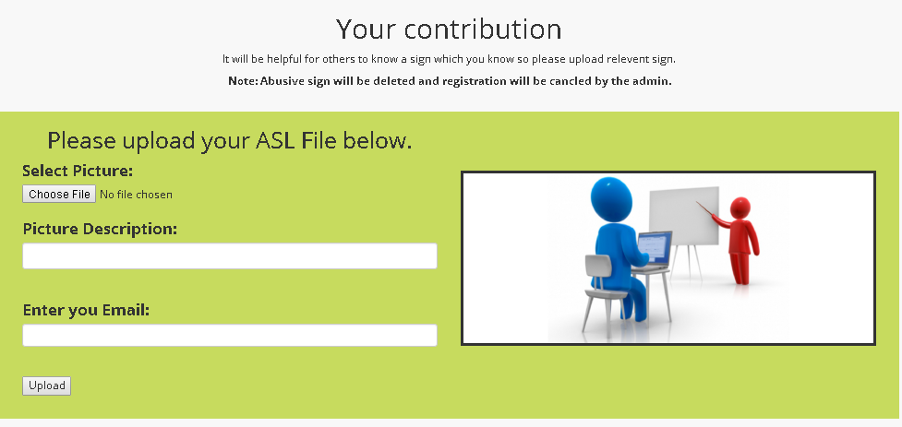

Only registered user can upload file so he/she have to enter email-id.

Click to select the file from your device

In this field user enter the description of his uploaded file.

**Section 1.4.2(iii) (manual learning slider):**

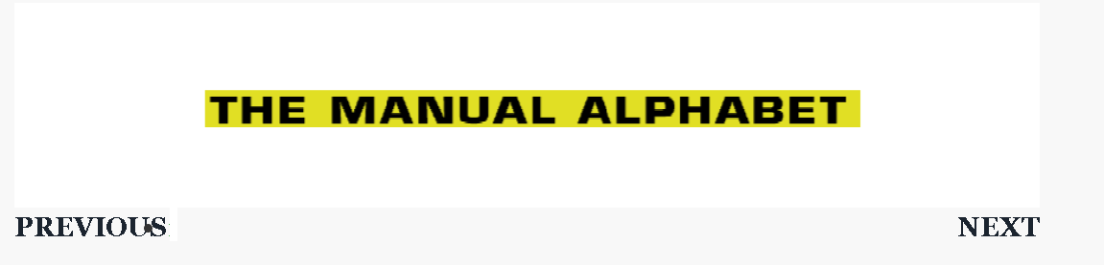

Click for next sign

Click for previous sign

**Section 1.4.2.2 For participating in Quiz:**

Click for quiz Window



**Section 1.4.2.2(i) Sub Section:**

This web page will appear after the selection of one of the option provided to user i.e. selected option is “Evaluate Your Self By participating in Quiz”.

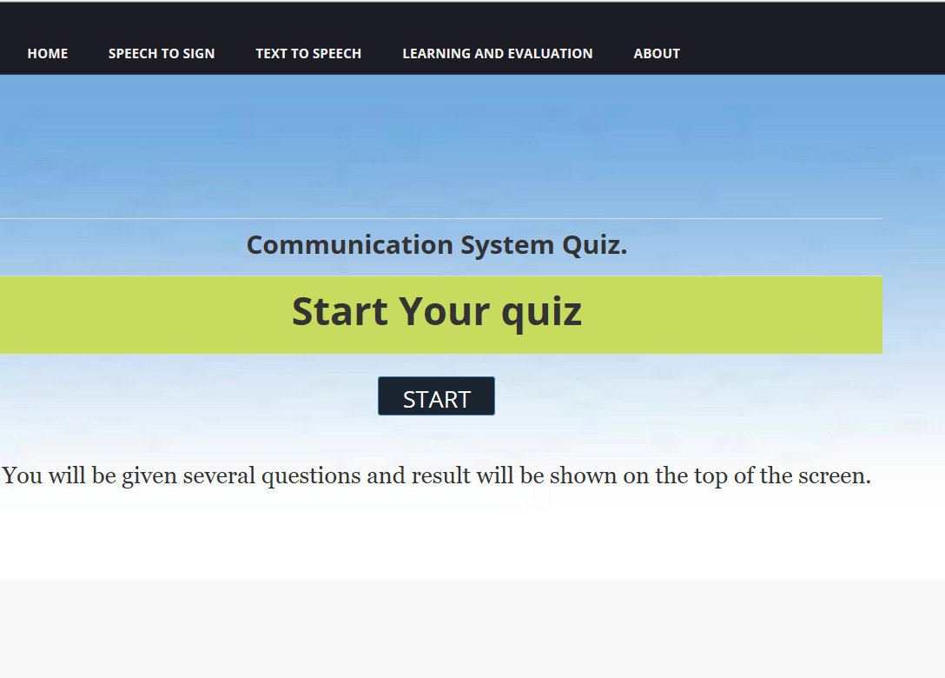

Clicking this button will start the quiz

**Section 1.4.2.2(ii) Sub Section:**

After clicking the button the following quiz web window will appear having multiple choice question this window provide quiz timer for users or participants and also user are evaluates according to their true or false options and score will be appear at the right corner of the window.

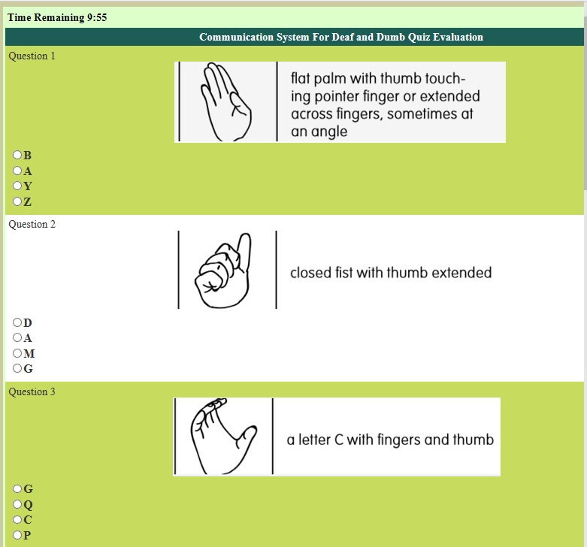

Quiz Timer

MCQ’s

Questions

**Section 1.4.2.2(iii) Sub Section:**

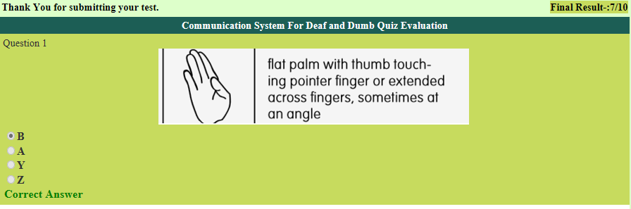

Total score after test

**Chapter 9**

**Conclusion**

**9.1 Conclusions and Future Enhancement:**

A Web Site: Talking Hands to reduce communication gap with Hearing and Speech Impaired persons is web base application so any one can use it but all other application on the other hand, discuss in the Chapter 2 are either hardware applications or are one-phase image processing applications. Some application use camera and Sensors while some use glove to give an input to the system. Our application is simple for everyone to use. Our application is two way communication that is it is not only for deaf and dumb but also for the normal people as well. There is another factor that all other application discuss in the chapter 2 are expensive to buy but our application is free to use. User just have to make an account for the learning purpose.

Most of the system are Glove base systems while for learning purpose most of them use SLIM Module, TESSA, Wi-See Technology, SWI_PELE System (Secure Wireless Infrastructures and Personalized Educational Learning Environments) and the Web Sign Technology. Our system uses Speech to Sign Application Programming Interface for communication while for learning purpose Text to Sign is used. These techniques help us in developing the system in less cost as compared to all other systems. Our system, not only help the user to learn the American Sign Language but it also help to update the database or vocabulary of the language which make it limitless with respect to data. We have provided an interface to the user in which user can upload signs relevant to the American Sign Language.

**9.1.1 Future Enhancement:**

We have develop this application on small scale for communication purposes and with less time and cost but in future this application can be updated by adding more and more signs not only by the developers but can also by the users. Admin of the application have an eye on the data uploaded by the users and irrelevant signs can be deleted from the database. Our future enhancement includes

* Updating the database time to time by adding more and more signs.
* Interface ehancement and adding new features to the application.
* Adding more and more technicality and functionality to the application.
* Maintaining the application and securing it from attacks.
* If the application might get populer than to develop the Andriod App of the same features.

**References:**

**[1]** Ghorpade, Shraddha R., and Surendra K. Waghamare. "Full Duplex Communication System for Deaf & Dumb People." International Journal of Emerging Technology and Advanced Engineering (IJETAE) 5.5 (2015).

**[2]** David J. Sturman, David Zeltzer, “A Survey of Glovebased Input”, IEEE computer graphics and applications, January 1994.

**[3]** Rigueira Cabrera, Alejandro. "Study of the use of wearable devices for people with different types of capability." PhD diss., 2017.

**[4]** Porter, Michael E. Competitive advantage of nations: creating and sustaining superior performance. Vol. 2. Simon and Schuster, 2011.

**[5]** Mr. Swaroop thool, “Wireless and un-instrumented communication by gestures for deaf and mute based on Wi-see technology”, IOSR Journal of Electronics and Communication Engineering (IOSR-JECE) Vol.7, Issue 6 (Sep. - Oct. 2013), PP 31-35

**[6]** Saraswathi, Anitha "Deaf Mute Communication Interpreter-A Review." International Journal of Applied Engineering Research 11 (2016): 290-296.

**[7]** Mittler, Peter. Working towards inclusive education: Social contexts. Routledge, 2012

**[8]** Padmanabhan, V., and M. Sornalatha. "Hand gesture recognition and voice conversion system for dumb people." International Journal of Scientific & Engineering Research 5.5 (2014): 427.

**[9]** Abdel-Masieh, Mina M., Manuel M. Nasief, and Maher M. Abdel-Aziz. "Smart Communication System for Deaf-Dumb People."

**[10]** K.V. Fale, Akshay Phalke, Pratik Chaudhari, Pradeep Jadhav “Smart Glove: Gesture Vocalizer for Deaf and Dumb People”, Vol. 4, Issue April 2016

**[11]** Goyal, Sakshi, Ishita Sharma, and Shanu Sharma. "Sign language recognition system for deaf and dumb people." International Journal of Engineering 2.4 (2013): 2013.

**[12]** Boraste, S. N., and K. J. Mahajan. "Image Processing based Language Converter for Deaf and Dumb." International Journal of Electronics, Communication and Soft Computing Science & Engineering (IJECSCSE) (2015): 191.

**[13]** Kakde, Manisha U., and M. Rawate Amit. "Hand Gesture Recognition System for Deaf and Dumb People Using PCA." International Journal of Engineering Science 1892 (2016).

**[14]** Seth, Dibyabiva, et al. "Real Time Sign Language Processing System." International Conference on Smart Trends for Information Technology and Computer Communications. Springer, Singapore, 2016.

**[15]** Raheja, Jagdish L., A. Singhal, and Ankit Chaudhary. "Android based portable hand sign recognition system." arXiv preprint arXiv:1503.03614 (2015).

**[16]** Sood, Anchal, and Anju Mishra. "AAWAAZ: A communication system for deaf and dumb." Reliability, Infocom Technologies and Optimization (Trends and Future Directions)(ICRITO), 2016 5th International Conference on. IEEE, 2016.